Differential Equations Project:

Research Question:
Which external variables increase or decrease media trust over time, and how can a media system be structured to maximize long-term trust?

model media trust at the country level

Questions:
- What type of “media” are you referring to?

My secret goal: how to restore trust in the media?

Core state variable:
T(t)=public trust in media at time t
0≤T(t)≤1

External Variables:
- E: economic stability
- G: government transparency
- I: institutional dynamics
- P: political polarization / political climate
- C: country-specific institutional strength
- A: AI-generated media intensity / AI/social media influence
- Education .. critical thinking ?
- Government control of the media
- Government trust??
- Political stability
- Media autonomy
- Age gap?
- Partisan gap?

Modeling Assumptions:
- media is polysemic and might refer to many – partly overlapping – different facets of media, in particular in contemporary high-choice media environments with a greater media abundance than ever ( https://academic.oup.com/anncom/article/44/2/139/7906093)

- Trust increases due to:
  - Economic stability
  - Transparent governance
  - Strong institutions
- Trust decreases due to:
  - Political polarization
  - Misinformation pressure
  - Uncontrolled AI content
- Trust erodes faster when current trust is high (expectation effect)

https://academic.oup.com/anncom/article/44/2/139/7906093
- ‘trust and confidence’ in ‘the mass media’ declined from 68 percent in 1968 to 32 percent in 2016 (source: https://news.gallup.com/poll/243665/media-trust-continues-recover-2016-low.aspx)
- Media trust: media credibility and media trustworthiness
  - Opposite: distrust, media cynicism, media skepticism
- news media users do not have at their disposal the resources and capabilities to evaluate thoroughly the reliability of news … Thus, somehow they have to find clues to legitimate their trust and to compensate for this inevitable risk
- source credibility
  - expertise
  - trustworthiness
- media credibility:
  - degree to which the media is perceived to be fair, unbiased, and accurate
- measurement of media trust
- most important function of news media is to select and convey the kind of information people need to understand politics and society
- More specifically, they posit that trust in news media consists of four separate dimensions: trust in the selectivity of topics, trust in the selectivity of facts, trust in the accuracy of depictions, and trust in journalistic assessment.

- what ‘media’ as in ‘media trust’ refers to. Early on, research noted that trust in and the credibility of television and newspapers tend to differ, although there is usually a correlation between the two
- Recent research has furthermore established that levels of media trust differ depending on whether it refers to news overall, news that people use, or news in digital and social media (Newman et al., 2019), whether it refers to an unspecified referent (such as ‘the press’ or ‘the media’) or specified news sources (Daniller et al., 2017; Eberl, 2019), and whether it refers to commercial versus public service broadcast news (Matsa, 2018). Media trust might also differ depending on whether it refers to national versus local media, across individual news media, and across the coverage of different topics
- news media trust refers to the relationship between citizens (the trustors) and the news media (the trustees) where citizens, however tacit or habitual, in situations of uncertainty expect that interactions with the news media will lead to gains rather than losses

https://www.oecd.org/en/publications/2025/11/oecd-survey-on-drivers-of-trust-in-public-institutions-in-latin-america-and-the-caribbean-2025-results_698c3d98/full-report/trust-and-information-integrity-in-latin-america-and-the-caribbean_e3084e6a.html?utm_source=chatgpt.com
- pdf: (https://www.oecd.org/content/dam/oecd/en/publications/reports/2025/11/oecd-survey-on-drivers-of-trust-in-public-institutions-in-latin-america-and-the-caribbean-2025-results_698c3d98/ea3385cf-en.pdf)
- Please cite this publication as:
- OECD (2025), OECD Survey on Drivers of Trust in Public Institutions in Latin America and the Caribbean 2025 Results, OECD
- Publishing, Paris, https://doi.org/10.1787/ea3385cf-en.

- Regional Trust Levels in Institutions
Trust differences between institutions and media across countries. Useful for validating how your model’s trust variable T(t) varies with political and institutional context

- On average in latin American and the Caribbean (LAC), about 35% of people express high or moderately high trust in their national government, while about 48% express low or no trust. This is somewhat lower than the average across OECD countries
- Trust in media (42%) is higher than trust in national government (35%) in LAC, which contrasts with OECD countries where trust in government and media are roughly equal (both about 39%)

- Information Consumption Patterns
Parameter: AI/social media influence (A) that affects trust. High reliance on social media suggests potential vulnerability to misinformation, which your model could treat as increasing the erosion term (trust decay).
- Social media is the dominant information source for political news: 72% of respondents use it for current affairs, well above the OECD average (49%)
- In LAC, people rely more on social validation cues (likes/shares to assess credibility)
- Media vs Government Trust Relationship
Suggests your model should allow institutional dynamics where media trust and government don ot move in lockstep
- Across LAC individuals trust news media more than their governments, unlike OECD average
- Correlates of Trust
- Perceptions of evidence-based decision making by government are associated with higher trust in national government
- Better explanations of government reforms are also positively correlated with trust
- Trust Drivers beyond Fundamental Institutions
While focus is media trust, trust is not uniform across institutions, and factors like satisfaction with basic services or perceptions of fairness can condition trust more broadly
- Trust levels vary significantly across institutions: the armed forced and police tend to be trusted more than the judicial system, legislature, or civil service
- Satisfaction with administrative services is typically higher than with healthcare or education
- Link between trust and economic conditions
These correlations support the inclusion of economic stability ( E) and political climate (P) in dfq equation. For example, increased economic insecurity could be modeled as increasing the trust decay rate k or decreasing the trust-building coefficient c
- Concern about unemployment, inflation, and poverty are among the top issues reported by respondents, and these economic concerns correlate with lower overall institutional trust
- Financial insecurity and worries about crime also coincide with lower trust in government
- Policy implications the report identifies
Actionable findings can be used to interpret results from your model. For instance, demonstrating in your model that increasing G (government transparency) increases the long-term equilibrium trust level T* provides a mathematically grounded conclusion consistent with OECD policy evidence
- Report suggests trust can be strengthened by:
  - Improving day-to-day service delivery and perceptions of institutional fairness
  - Enhancing the clarity, accessibility, and quality of public communication
  - Using evidence and transparency in decision-making processes

This report presents the main findings of the OECD's first Survey on the Drivers of Trust in Public Institutions carried out in Latin America and the Caribbean (LAC), the first regional exercise of the OECD Global Trust Survey Project. It illustrates levels of trust in different public institutions and explores how people’s experiences with, and expectations of, government influence trust.
These expectations range from day-to-day interactions with public institutions to government decision making on complex policy issues. The survey was conducted in ten countries in 2023 and 2025

Slightly more than one-third (35%) of people in LAC place high or moderately high trust in the national
government, while close to one in two (48%) have low or no trust. Trust is lower in LAC than in OECD
countries, where 39%, on average, have high or moderately high trust in the national government.
In both LAC and OECD countries, police and security institutions receive the highest trust ratings, while
legislatures and political parties receive the lowest. Local government is more trusted in LAC (37%) and
the OECD (45%) than national governments. In contrast to the OECD average result, a smaller share of
people in LAC report high or moderately high trust in the civil service (32%) compared to the national
government.
Perceptions of political voice and partisanship are more strongly associated with trust gaps than socio-
economic and demographic characteristics are, echoing results across the OECD: 66% of LAC
respondents who feel people like them have a say in government decisions trust the national government,
compared to 21% among those who feel they lack voice. Perceived financial and physical insecurity is also
associated with low trust. Differences in trust between the young and old, and between men and women,
are notably smaller in LAC than across the OECD.

- relationship between information exposure and trust in public institutions across LAC
Key findings:
- trust in media exceeds trust in government:
  - 42% of Latin Americans trust news media, compared to 35% who trust national governments. . In contrast, in OECD countries, the trust levels for both institutions are equal (39%)
- social media dominates information about current affairs:
  - 72% of respondents use social media for political news, far above the OECD average of 49%. Social validation (such as “likes” and “shares”) plays a larger role in assessing news credibility in LAC than in the OECD.
- information consumption correlates with trust:
  - People who consume political news –regardless of source – tend to have higher trust in government. However, trust gaps between media users and non-users are narrower in LAC than in OECD countries.
- perceptions of evidence-based decision making, a crucial driver of trust in national government and the civil service, remains mixed
  - Only 38% believe governments use the best available evidence for policies, with strong partisan divides in perception. People with a positive view of evidence-informed decision making are significantly more likely to place high or moderately high trust in the national government, civil service and the national legislature. Likewise, less than one-quarter of respondents find official statistics trustworthy, understandable, or easy to find.

- there are communication gaps on reforms and concerns about disinformation :
  - Only 38% believe governments use the best available evidence for policies, with strong partisan divides in perception. People with a positive view of evidence-informed decision making are significantly more likely to place high or moderately high trust in the national government, civil service and the national legislature. Likewise, less than one-quarter of respondents find official statistics trustworthy, understandable, or easy to find.

https://www.edelman.com/sites/g/files/aatuss191/files/2024-01/2024%20Edelman%20Trust%20Barometer%20Global%20Report_FINAL_1.pdf?utm_source=chatgpt.com
2024 edelman trust barometer
metrics
- 28 Countries: Argentina, Australia, brazil, Canada, china, Colombia, France, Germany, india, Indonesia, ireland, italy, japan, kenya, malaysia, mexico, netherlands, Nigeria, Saudi arabia, Singapore, s. Africa, s. korea, spain, Sweden, thailan, UAE, UK, US
- 32K+ respondents
- ~1.150 respondents per country

- Trust index 2023 to 2024: developing countries lead on trust

  - Trust index: average percent trust in NGOs, business, government, and media 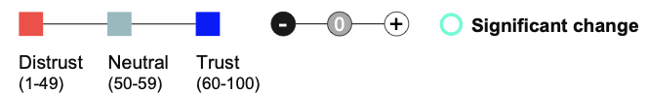
- Establishment leaders not trusted to tell us the truth:
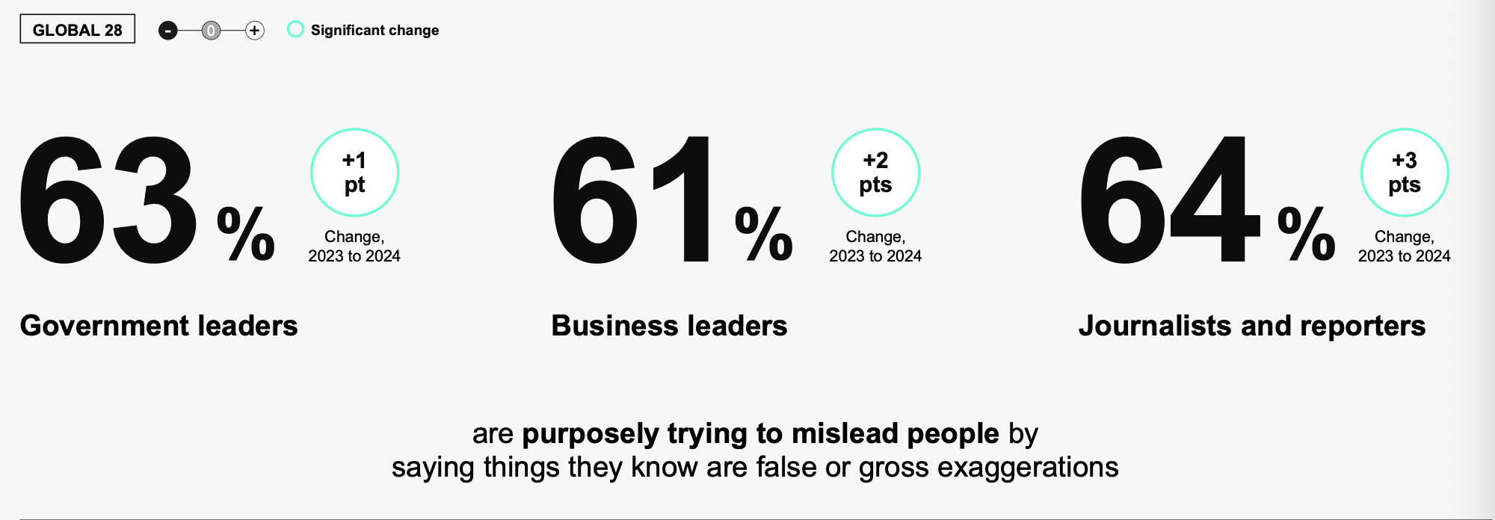

https://www.oecd.org/en/publications/2024/07/oecd-survey-on-drivers-of-trust-in-public-institutions-2024-results_eeb36452/full-report/trust-and-information-integrity_49ce5100.html?utm_source=chatgpt.com

OECD Survey on Drivers of Trust in Public Institutions – 2024 results
- Building trust in a complex policy environment
- The information people are exposed to can affect their perceptions of, and trust in, public institutions. This chapter examines the relation between people's trust in news media, their news consumption habits, their criteria for judging the credibility of a news story and their trust in the government. It then examines how people view public communication, both with regard to administrative services and major policy reforms. Finally, it explores people’s expectations of government use of evidence in public decision making, and how these views contribute to trust.

A solid information ecosystem providing quality information is vital for people to make informed judgements about government actions and hold public institutions accountable. Along with an education system that equips people with the cognitive and critical skills and knowledge to process the information, this ecosystem helps individuals form “sceptical trust” in public institutions. Such sceptical trust is crucial in protecting democracy from the threats of disinformation (Norris, 2022[2]). However, disruptive trends such as the proliferation of mis and dis information, polarising speech on mass communication channels, informational echo chambers and decline in media pluralism and diversity can weaken the information environment. In this context, OECD work defines a framework to reinforce and protect information integrity, defined as “information environments that are conducive to the availability of accurate, evidence-based, and plural information sources and that enable individuals to be exposed to a variety of ideas, make informed choices, and better exercise their rights” (OECD, 2024[3]).

As part of the growing difficulties with the evolution of the information environment, trust in traditional media is also suffering. On average, 39% of individuals in OECD countries have high or moderately high trust in news media, mirroring levels of trust in the national government, while 44% report low to no trust in the media (Figure 5.1). Only in Belgium, Canada, Finland, Iceland and the Netherlands does the majority of the adult population have high or moderately high trust in the news media. The average level of trust in news media across OECD countries has nevertheless remained steady between the 2021 and 2023 waves of the OECD Trust Survey, although with large variation in some countries (

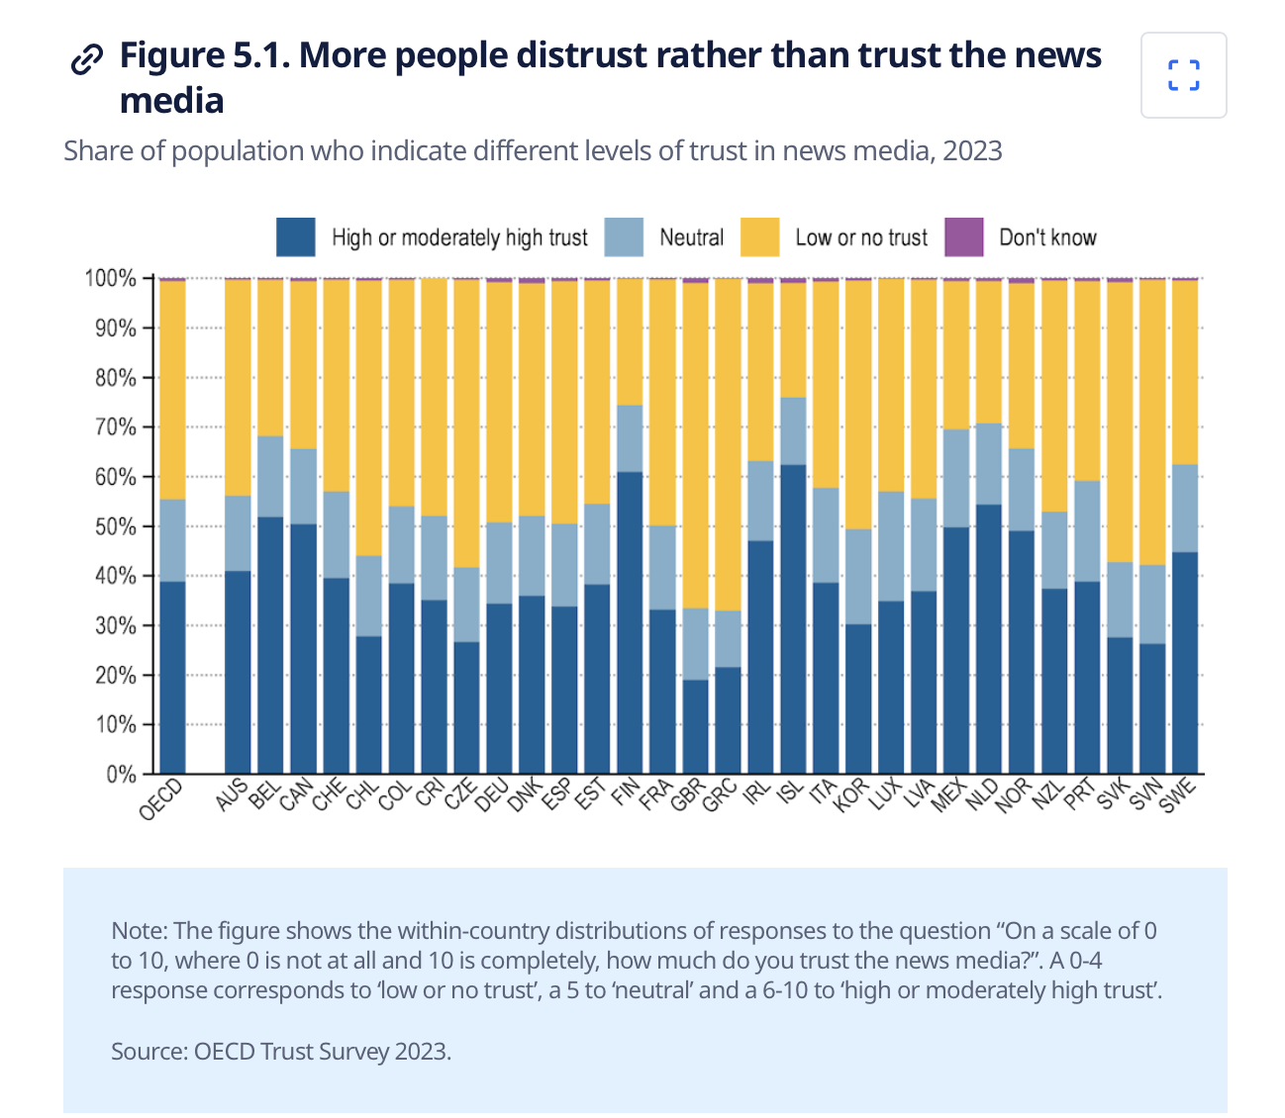
- responses to the question “On a scale of 0 to 10, where 0 is not at all and 10 is completely, how much do you trust the news media?”. A 0-4 response corresponds to ‘low or no trust’, a 5 to ‘neutral’ and a 6-10 to ‘high or moderately high trust’.

- An independent and pluralistic media environment is a fundamental principle of democracy as it facilitates the public’s ability to scrutinise the actions of high-level political officials and policy-makers and to make informed choices. For instance, Guriev and Treisman (2019) raise the spectre of "informational autocrats" coercing citizens into compliance through information manipulation

An independent and pluralistic media environment is a fundamental principle of democracy as it facilitates the public’s ability to scrutinise the actions of high-level political officials and policy-makers and to make informed choices. For instance, Guriev and Treisman (2019) raise the spectre of "informational autocrats" coercing citizens into compliance through information manipulation

People’s trust in government is found to be closely related to their news consumption habits. Only 22% of those who prefer not to follow political news report high or moderately trust in the government, while the share is 40% among those who follow the news in some way (Figure 5.3). Additionally, individuals who keep up with politics or current affairs through TV, Radio, or written press tend to trust the national government more than those who do not use these media. However, trust levels are virtually the same among those who use social media for news (39%) and those who do not (40%). This may be because news consumption via social media, in turn, is not conducive to high political knowledge (Castro et al., 2022[6]). Similarly, there is little difference in trust between those who discuss news with friends or family (41%) and those who don’t engage in such conversations (38%). Of course, these associations may also owe to socio-economic factors that influence people’s choices of media or interest in news

Figure 5.4. Younger people rely more on social than traditional media

Share of population who indicate that they get information about politics and current affairs from respective source, unweighted OECD average, 2023

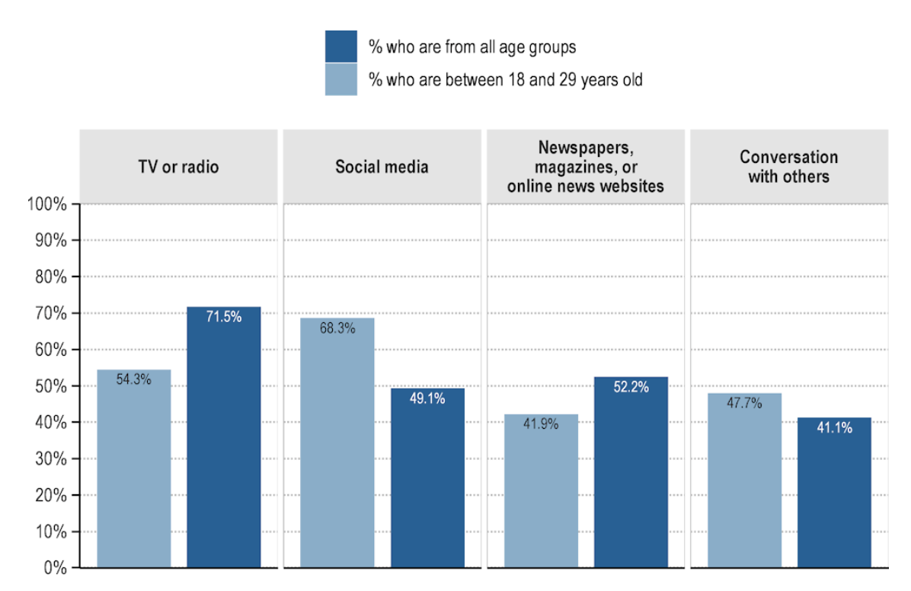

- Tv radio
- Social media
- Newspapers, magazines, or online news websites
- Conversation with others
- Effective and inclusive government communication can enhance trust in public institutions
- Copy link to 5.3. Effective and inclusive government communication can enhance trust in public institutions
- In addition to journalists, social media influencers and peers, public institutions can also serve as sources of information. These entities can disseminate information directly via public websites, informational campaigns, and press conferences, or indirectly, through the information passed on to journalists by high-level political officials and civil servants. This provision of information is one aspect of public communication, which encompasses the “exchange of information between government and citizens, and the dialogue that ensues from it

https://www.edelman.com/trust/2025/trust-barometer..
https://www.edelman.com/sites/g/files/aatuss191/files/2025-01/2025%20Edelman%20Trust%20Barometer%20Global%20Report_01.23.25.pdf

- Lack of quality information
  - Deep sense that the political system is broken
- 2025 Edelman Trust Barometer: Data Analysis in Detail
- Countries With National Elections or Changes in Government Leadership
- To understand the impact that a change in government
- leadership has on trust, we identified the countries in our study
- that had an election or other government leadership change
- between the survey fielding dates for the 2024 Trust
- Barometer (Nov 3 – Nov 22, 2023) and the 2025 Trust
- Barometer (Oct 25 – Nov 16, 2024). Elections or other
- government leadership changes were defined as a national
- election, the collapse of coalition, or the appointment of a new
- prime minister.
- Date of change Description of change
- Argentina November 2023 Run-off Election
- France June, September 2024 Election; Collapse of leadership coalition
- Germany November 2024 Collapse of leadership coalition
- India April to June 2024 Election
- Indonesia February 2024 Election
- Japan October 2024 Election
- The full list of countries included in the analysis, referenced on
- pg. 6 of the 2025 Global Report, is shown in the table at right
- Mexico June 2024 Election
- Netherlands November 2023 Election after cabinet collapse in July 2023
- S. Africa May 2024 Election
- S. Korea April 2024 Election
- Thailand August 2024 New Prime Minister appointment
- UK July 2024 Election
- U.S. November 2024 Election

https://www.oecd.org/content/dam/oecd/en/publications/reports/2024/06/oecd-survey-on-drivers-of-trust-in-public-institutions-2024-results-country-notes_33192204/switzerland_133eef64/b0df7353-en.pdf
- 2023: 62% of swiss people reported high or moderately high trust in the federal government above the OECD average of 39%

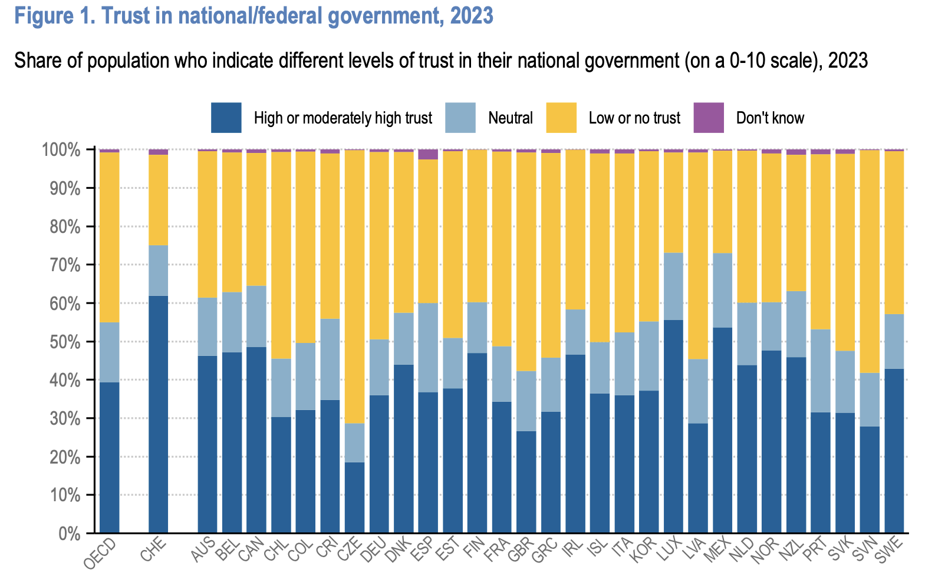
Note: high or moderately high: corresponds to the aggregation of response options 61- to the question: “on a scale of 0 to 10, where 0 is not at all and 10 completely, how much do you trust your national/federal government?
Similarly to most OECD countries, Swiss people place more trust in the police (75%), courts and the judicial system (69%) and other people (65%) than in the national government. More than half of the population reports high or moderately high trust in the national parliament (53%), the national civil service (56%) and local government (63%). Political parties (38%) and news media (40%) are the least trusted institutions in Switzerland.

https://www.pewresearch.org/short-reads/2025/10/29/how-americans-trust-in-information-from-news-organizations-and-social-media-sites-has-changed-over-time/
- Conclusion: Trust in media in the USA is declining
- How americans trust in information from news organizations and social media sites has changed over time
- Americans’ trust in information from national and local news organizations has declined after a slight increase earlier this year, according to a new Pew Research Center survey. The decline has occurred in both major political parties and across all age groups.

- 56% of U.S. adults now say they have a lot of or some trust in the information they get from national news organizations – down 11 percentage points since March 2025 and 20 points since we first asked this question in 2016.
- trust in information from localnews organizations remains higher (70%), although it has also dropped – from 80% in March and 82% in 2016.
- Fewer than half of Republicans and Republican-leaning independents (44%) now say they have at least some trust in the information that comes from national news organizations. This is down from 53% in March and 70% in 2016, but it’s still above its lowest point in 2021, when 35% of Republicans expressed this level of trust in the national media
- As in the past, Democrats (including leaners) are more likely than Republicans to trust information from national and local news organizations. But Democrats’ trust in both types of organizations has also fallen in recent months. Today, 69% of Democrats have at least some trust in information from national news organizations. This is the lowest level recorded since we began asking the question, and down from 81% in March. Meanwhile, 78% have this level of trust in information from local news organizations, down from 87% earlier this year.
- Republicans and Democrats are equally likely to say they have at least some trust in information from social media sites (37% in each group say this). Republicans are now lesslikely to trust this information than they were earlier this year (down 8 percentage points) after a period of steady increase. The share of Democrats who say they have at least some trust in information from social media sites has remained relatively consistent over the past several years.

- Trust in national and local news media declines across all age groups
- Americans under 50 are slightly less likely than those ages 50 and older to have trust in information from national and local media. Still, across all age groups, trust in these organizations has declined over the last several months.
- 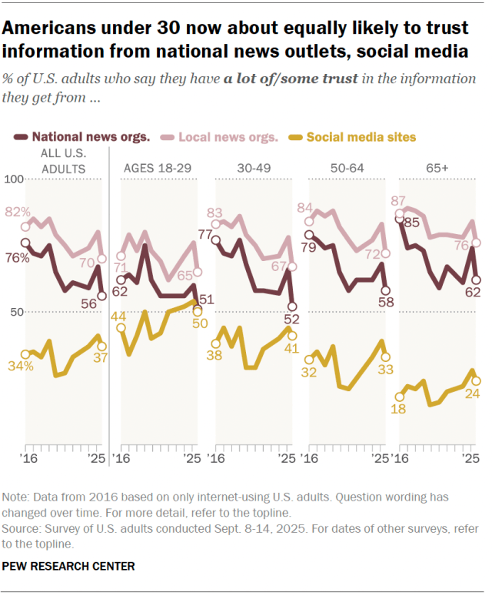
- Today, only around half of adults under 50 (52%) have a lot of or some trust in information from the national news media. Adults under 30, in particular, are now about as likely to say they trust information from national news organizations (51%) as they are to trust information from social media sites (50%). Older age groups, in turn, are more likely to trust national news organizations than social media.
- Trust in local news organizations remains higher than trust in national news organizations among Americans of all ages.
- Younger Democrats express less trust than older Democrats in national and local news
- Trust in national and local news organizations also varies by party and age, especially among Democrats.
- 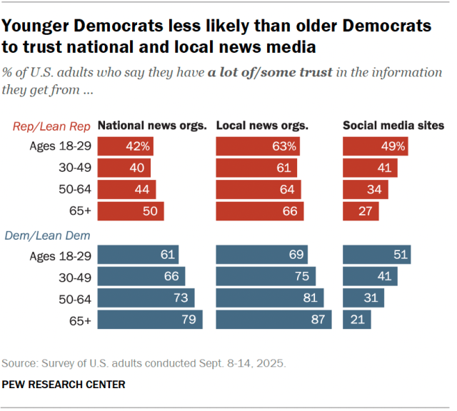
- In the new survey, 79% of Democrats ages 65 and older say they have at least some trust in information from national

https://thetrustproject.org
- Best practices: do you know who’s behind the news?
- Journalist expertise: who made this?
- Labels: news? Opinion? Or what?
- References: what’s their source?
- Methods: how was it built?
- Locally sourced: do they know you? Your community?
- Diverse voices who’s in the news? Who’s missing?
- Actionable feedback does this news site listen to me?

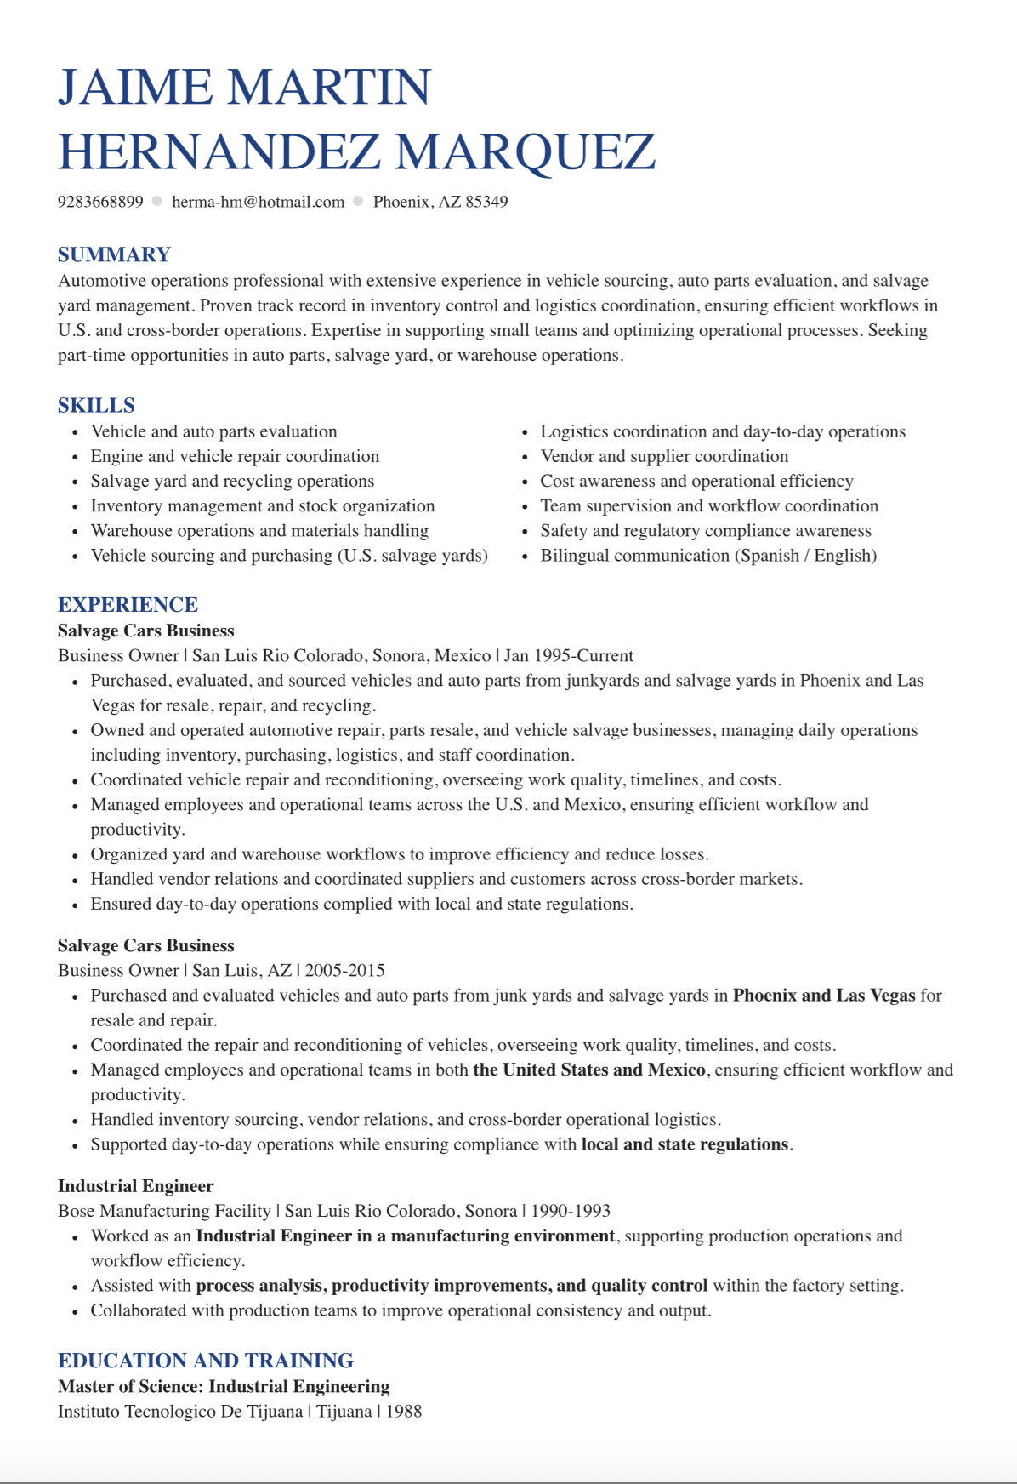

https://onlinelibrary.wiley.com/doi/full/10.1111/aspp.12715?casa_token=hznwx9_R1hkAAAAA%3ABhrnyhukyCueMcEO8fGUr6z2SkANI-U4im1-eHst3mUHxhoJyLsFVul5sP2DhualVmuFPyghyZe7eQ
- Declining levels of trust in the media in western democracies
- Examine logic behind trust in three different types of regimes in East and Southeast Asia: countries with, partial, and no press freedom
- 12 countries
- Internet usage, online political participation, support for media censorship, and patriotic belief have different associations with the variable being studied as the degree of press freedom varies
- Findings indicate that citizens are well aware of the role mass media plays in the political system and thus their trust in the media reflects the expectation-perception gap of the government-media relationship
- Mass media has long played a critical role in society by providing essential information, shaping public opinion and ideas, enhancing pluralism, and serving as the “fourth estate” holding government accountable for its actions and policies. Nonetheless, the declining public trust in mainstream news organizations has been noted around the world and been a subject of concerned for academic scholars over the years, especially in Europe and the Americas
- While the public trust in television is generally high, the figure shows that in democracies such as Japan, Korea, and Taiwan, where journalists can freely express their observations and views, people have relatively low trust in mainstream media outlets. Nonetheless, in authoritarian regimes such as China, Vietnam, and Singapore, where press freedom is strictly constrained by the government, about 90% of interviewees indicated trust in television. In short, Figure 1 gives rise to a puzzle: the more a government jeopardizes freedom of expression and information, the higher the public's trust in television outlets.
The government regulates the freedom of the news media with laws; and the news media can either serve as a watchdog or a mouthpiece of the government. Considering the different roles the media plays in different types of regimes, the incentives associated with people's trust in mass media should be different. The above discussion calls for comparative research into the different motivations behind public trust in media in various types of political regimes.

We assert that both institutionalists and culturalists capture important aspects of trust; the former of which argues that differences in trust are attributed to institutional performance, while the latter prefers to explain differences based on culture and environment

approach to examining media trust integrates both sides of the debate, revolving around the interaction between the perceived institutional performance of news media and individual values, attitudes, and beliefs of news organizations formed during the socialization process

We further derive our theoretical assumptions which suggest that different factors may account for public trust in media in different regimes
Asian Barometer Survey (ABS) data, in the fourth section, our main findings show that, while respondents' trust in government and support for socioideological control of the government have consistent and significant associations with their media trust across all East and Southeast Asian countries, Internet usage, online political participation, support for media censorship, and patriotic belief have different associations with the variable being studied as the degree of press freedom varies. This reveals that citizens are well aware of the role mass media plays in the political system and thus their trust in the media reflects the expectation-perception gap of the government-media relationship. In the conclusion section, we discuss the theoretical and normative implications of our findings and provide theoretical insights for further research

two main schools of thought: the “institutional” and the “cultural” schools. The former conceptualizes media trust as consequences of source credibility and considers it as a means for information receivers to evaluate the source or transmitter of information

evaluation often correlates with the receivers' willingness to attribute truth and substance to the information. For example, Hovland et al. (1953) suggested trustworthiness and expertise as two main components of source credibility. Gaziano and McGrath (1986) also found that fairness, unbiasedness, comprehensiveness, accuracy, and objectiveness of news coverage are indicators of source credibility. Based on this definition, institutionalists attributed the declining trust in news media to the lack of high-quality reporting media bias game-framed news and the challenge from social media

cultural school, on the other hand, views the formation of trust in media as a socialization process through which individuals expose themselves to the information environment, and hence develop and cultivate their own beliefs, values, or tendencies and project them onto political and news institutions. Those beliefs, values, and tendencies further mold a shared identity among certain people and thus influence their views and attitudes toward the news media. For instance, scholars generally agree that trust in others (Müller, 2013), trust in government or other political institutions (Hanitzsch et al., 2018; Jones, 2004; Lee, 2010), and levels of political interest (Tsfati & Ariely, 2014) are correlated with trust in media. Lee (2010) investigated the American National Election Studies data gathered from 1996 to 2004 and found that the liberal-oriented ideology and pro-Democrats were positively associated with trust in media. Hanitzsch et al. (2018) also viewed the dramatic decline in media trust as a marker of substantial issues driven by the growing presence of antielitism in political discourse
cross-national data such as the World Value Survey (WVS) and ABS allow analyses of the variance in the extent of trust in mass media from a comparative perspective and investigation into how contextual factors are associated with media credibility. For instance, Shirikov (2020) studied WVS data and concluded that there is no significant decline in media trust among stable democracies, but this is not the case in democratizing countries and in countries that have undergone substantial political reform. Tsfati and Ariely (2014) examined media trust in 44 countries and found that the degree of country-level postmaterialism is significantly associated with trust in media, and state ownership of television has different associations with media trust in different regimes. Ariely (2015) analyzed survey data from 32 European countries and found that systematic factors including media autonomy, journalistic professionalism, and party-press parallelism can explain why European citizens hold different views regarding their trust in news media. However, Kalogeropoulos et al. (2019) investigated media trust in 35 countries and found the levels of press freedom are not significantly associated with trust in the news media. In brief, due to the lack of a concrete research framework, the findings above are inconsistent.

In the political system, mass media provides essential information in a timely manner to citizens and plays an important role in the socialization process of an individual. The government imposes regulations on media outlets. Violating the media laws could result in fines or having their license revoked. Under the government regulation, news media outlets can serve as a watchdog over the incumbents, responsible for fact-checking, reporting government wrongdoings, and interviewing political and public figures to increase accountability; or simply serve as a government mouthpiece, concealing information unfavorable to the ruling party and propagandizing the ideas of its leaders as a way of life. Citizens are responsible for evaluating the quality of the content of the news. They possess a prior belief of a “good” media acquired through the self-socialization process of daily information seeking and then compare what they observe on a daily basis with their expectation. Next, they decide whether or not to bestow their trust in the news media and if so, then to what extent.

In a modern democracy, the underlying purpose of mass media is to help discover the truth, to provide essential information in a timely manner which permits citizens to voice their demands to public officials, to limit official discretion, to increase controls over officials, and to reduce state power

news media does not necessarily act as a watchdog over the incumbents

In East Asian democratic countries, although there has been significant progress in media freedom, the media is still influenced by politics. In Japan, the government usually exerts pressure on the news media, which results in heavy self-censorship on sensitive topics such as corruption, sexual harassment, and health issues (Reporters Without Borders, 2023). Similarly, in South Korea, the government was criticized for attempting to influence unfavorable news and information content (Freedom House 2011). In Taiwan, the society has become deeply divided along partisan lines, with each group having its own distinct mobilization networks and mass media outlets (Huang, 2011). Due to the polarization of politics between Pan-Blues and Pan-Greens in Taiwan, only 46% of respondents said that they trust television news. In Mongolia, the media openly show their affiliation with the government or political parties (Reporters Without Borders, 2023). The discussion thus explains the low media trust in democratic countries. Because of the strong connection between the government and the news media, government trust, and media trust are correlated in East Asian democratic countries. For those who value media transparency, objectivity, openness, and accountability, when they believe that news coverage is subject to government intervention and loses its impartiality, they will lose trust in the news media outlets and the government

News Media in Countries with Less Press Freedom

Khan studied 20 Philippine journalists' perceptions of press freedom and found that most of them had suffered different forms of harassment and false accusations from the government (Kahn, 2022). In Malaysia, Myanmar, Indonesia, and Thailand, persisting ethnic conflicts and interreligious violence have fostered a national security culture prevalent in society that requires the government to maintain social order and this serves as a justification to curtail media freedom…
allegations of undermining “national security” or “peace and order” can lead to imprisonment, journalists carefully self-censor their news reports or simply become the government's mouthpiece to stay out of trouble
Transparency, objectivity, openness, accountability, and integrity are not codes of ethics applied to journalism. In the social culture that emphasizes national security and social order, we can expect a closer relationship between public trust in the media and trust in the government.

In Singapore, China, and Vietnam, media surveillance authorities can further use media as a nationalist tool by requiring media outlets to promote certain favorable beliefs such as “national interests” and “decency” of their governance
For instance, Chang (2020) found that a series of patriotic indoctrinations launched by the Chinese Communist Party (CCP) government through schools and mass media since 1993 had significantly encouraged citizens, especially members of the older generations, to subordinate their own interests and accommodate themselves to the low government provision of welfare service. Knowing that the media institutions serve as a megaphone for government propaganda, citizens in authoritarian countries certainly have different expectations of the news media and the difference thus leads to a different foundation of media trust in countries with no press freedom

The news media can either be a watchdog over the incumbents, responsible for fact-checking, reporting government wrongdoing, and interviewing political and public figures to increase accountability, or simply serve as a government mouthpiece, concealing information unfavorable to the ruling party and propagandizing the ideas of its leaders as a way of life. Among the different roles the media plays in a political system, it is reasonable to assume that the foundation of media trust in different types of regimes might be different.

THEORETICAL HYPOTHESES

discuss thoroughly the factors and how they are jointly associated with public trust in media across different regimes, we first classify 12 East Asian and Southeast Asian countries into three different categories based on the 2020 World Press Freedom Index published by Reporters Without Borders (RSF): Japan (28.86, Rank 66), South Korea (23.7, Rank 42), Taiwan (23.76, Rank 43), and Mongolia (29.61, Rank 73) enjoy full media freedom. The group of partial press freedom includes Malaysia (33.12, Rank 101), Indonesia (36.82, Rank 119), the Philippines (43.54, Rank 136), Thailand (44.94, Rank 140), and Myanmar (44.77, Rank 139). Authoritarian countries such as China (78.48, Rank 177), Singapore (55.23, Rank 158), and Vietnam (74.71, Rank 175) fall into the group of no press freedom.

goal in this article is to show that the foundation of media trust varies across different regimes. Since public trust in the media, as demonstrated above, is strongly associated with its relationship with the government, we have employed a series of questions about respondents' political attitudes and perceptions towards media freedom in the country in which they live. These are as follows

Trust in Government and Patriotism

H1: Trust in government is consistently and positively associated with media trust across three different regimes.
H2.The patriotic belief is positively associated with media trust only in countries with partial and no press freedom, but not in the countries with full press freedom.

H3.Public support for socioideological control is positively correlated with media trust in all types of political regimes.

Media censorship occurs when a government requires news outlets to deceive its citizens by concealing, faking, distorting, or falsifying information (Xu & Albert, 2017). While this is a hallmark of authoritarian regimes, in democratic countries it is constrained by the constitution and applicable laws. Therefore, we can expect a positive association between citizens' support for media censorship and media trust. Such a relationship, however, should not exist in industrial or fledgling democracies.
H4.Public support for media censorship only positively correlates with media trust in a regime without press freedom, but not in countries with a fully free or partially free media.

Internet Usage and Online Political Participation

H5.Internet usage has a negative association with trust in mainstream media in the countries with partial or full press freedom, but not in authoritarian countries.

H6.Online political participation has a negative association with trust in mainstream media in the countries with partial or full press freedom, but not in authoritarian countries.

Studies/ data collection: https://asianbarometer.org

The ABS measured institutional trust in the media using the following question: “how much trust do you have in each of the following types of media?” The relevant category in the questionnaire was “the television.” Government trust was scaled in a similar way, despite slightly different wording. We then accounted for ideological patriotism by looking at the extent to which people are willing to sacrifice their own interests for the sake of national interests. With regard to public support for socioideological control over society, we used the following question in the ABS: “the government should decide whether certain ideas should be allowed to be discussed in society.” The ABS further measured public attitudes toward media censorship and freedom of the press by providing two statements: “the media should have the right to publish news and ideas without government control;” and “the government should have the right to prevent the media from publishing things that might be politically destabilizing.” Respondents were then required to choose the statement with which they agree the most. To estimate the degrees of a respondent's Internet usage and online political engagement, the ABS asks the interviewees, “How often do you use the Internet, either through a computer, tablet or smartphone?” and “please tell me whether you have used the Internet including social media networks to express opinions about politics and government.” The wordings, coding, and scaling of the variables above can all be found in the Appendix.
demographic factors such as gender, age, and education levels are also included. We also control for respondents' home countries by including country dummies

Model 1 respectively examines the relationship between major explanatory variables and trust in television in three different regimes and the findings agree with our theoretical hypotheses. That is, trust in government consistently and positively correlates with trust in media across the three types of political regimes. In East and Southeast Asian countries, media organizations generally have a low degree of autonomy. Even in Japan, a leading industrial democracy, politicians have at times been accused of attempting to influence the public media organization NHK News (Benson et al., 2017, p. 11). Similarly, in South Korea and Taiwan, media autonomy is relatively low because newspapers and television had long been controlled by nationalist governments ruled by the Democratic Justice Party and the Kuomintang, respectively. This explains why trust in government is significantly associated with trust in television in 12 East Asian countries. More interestingly, controlling for other variables, while the estimated coefficient of government trust for countries with full press freedom is 0.152, its counterparts for countries with partial and no press freedom are 0.207 and 0.332, respectively, showing that the more control the government imposes on news media, the higher the association between government trust and media trust. This finding is reminiscent of Ariely's cross-national study of media trust in Europe which states that “trust in the media and trust in government are relatively independent of one another when the media possess(es) a high degree of autonomy” (Ariely, 2015). As the degree of media autonomy decreases, we can expect an increase in the association between trust in government and trust in mass media.

Table 1. The cross-national analysis of trust in television in East and Southeast Asia.
 | Model 1 |  |  | Model 2
 | Full Freedom | Partial Freedom | No Freedom | Full Freedom | Partial Freedom | No Freedom
Trust in Government | 0.152***  0.013 | 0.207***  0.016 | 0.332***  0.014 | 0.146***  0.013 | 0.186***  0.016 | 0.250***  0.014
Patriotism | 0.016  0.018 | 0.097***  0.019 | 0.078  0.019 | −0.009  0.018 | 0.091***  0.019 | 0.135***  0.019
Support for Socioideological Control | 0.094***  0.019 | 0.029  0.019 | 0.076***  0.019 | 0.120***  0.019 | 0.041**  0.019 | 0.147***  0.018
Support for Media Censorship | 0.043  0.029 | 0.042  0.033 | 0.094***  0.027 | 0  0.030 | −0.004  0.033 | 0.072**  0.028
Internet Usage | −0.035***  0.006 | −0.008  0.007 | 0.008*  0.005 | −0.029***  0.007 | −0.011  0.008 | 0.005  0.006
Online Political Engagement | −0.057***  0.016 | −0.039**  0.017 | −0.013  0.014 | −0.073***  0.017 | −0.041**  0.017 | −0.023  0.015
Political Interests |  |  |  | 0.058***  0.012 | 0.052***  0.012 | 0.030***  0.009
Social Trust |  |  |  | −0.028  0.022 | 0.107***  0.022 | 0.106***  0.022
Age |  |  |  | 0.001  0.001 | −0.003**  0.001 | −0.005***  0.001
Gender |  |  |  | 0.056**  0.029 | 0.086***  0.033 | 0.121***  0.025
Education Level |  |  |  | −0.020  0.010 | −0.017**  0.008 | 0.003  0.007
Internet Penetration Rate |  |  |  | −0.011***  0.001 | −0.009***  0.001 | 0.004**  0.003
Country | Base: Japan | Base: Philippines | Base: China
Korea | 0.204***  0.041
Mongolia | 0.687***  0.051
Taiwan | −0.434***  0.042
Thailand |  | −0.026  0.058
Indonesia |  | −0.331***  0.051
Malaysia |  | −0.429***  0.048
Myanmar |  | −0.011  0.062
Singapore |  |  | 0.173***  0.037
Vietnam |  |  | 0.560***  0.037
Intercept | 3.51***  0.111 | 3.410***  0.147 | 2.232***  0.134 | 4.323***  0.182 | 3.50***  0.192 | 1.641***  0.258
N | 3999 | 3420 | 4842 | 3948 | 3369 | 4797
- *** p < 0.01
- ** p < 0.05
- * p < 0.1.
- Data Source: ABS.
- media autonomy is not appreciated in East and Southeast Asia. According to the ABS data, in most East and Southeast Asian countries except Japan and Taiwan, a majority of citizens agree to empower the government to decide whether certain ideas should be allowed to be discussed in society to maintain national security and social order. The national security culture thus justifies the government's intervention in the news business and its use of media as a socialization tool. As the culturalists suggest, because the public is influenced by the prevailing national security culture in East and Southeast Asia, it judges media performance based on whether news media can assist the government in maintaining social order and safeguarding national security. Therefore, the estimated coefficients of the support of socioideological control show a consistent and positive correlation with trust in television in the three different regime types.

- Our finding shows that high support for government ideological control, however, does not necessarily give the government a green light to further tighten its grip on mass media. For instance, according to the ABS data, in the Philippines and Thailand, although a clear majority of respondents (Philippines 68%, Thailand 51%) supported government's control over ideology, only around 30% agreed to grant the government power to censor mass media. In contrast with citizens in countries with full and partial freedom, those in authoritarian countries (Vietnam 58% vs. 58%; Singapore 57% vs. 44%; China 74% vs. 59%) are more consistent in their support for ideological control and media censorship. In other words, for citizens of authoritarian countries, whether the media adequately serves as the government's mouthpiece and propaganda tool becomes an important criterion for evaluating news media. Therefore, although the support for media censorship, as predicted, has a positive association with media trust in all three regimes, it only shows statistical significance in the regime type without press freedom.

Last but not least, Model 1 shows that the use of the Internet and online political engagement have different associations with public trust in the media in different types of regimes. In democracies with full press freedom, as predicted by our assumption, the more frequently people use the Internet and express their political opinions through the Internet, the lower their trust in television. These findings reflect the institutional school's argument that the Internet's proliferation over the past two decades has quickly gained public support and had a significant impact on public trust in traditional media sources. Unlike mainstream media organizations that are generally regulated by media laws and administration guidelines and often closely affiliated with political and economic elites, Internet-based social media platforms allow individuals to discuss and comment on news stories in an interactive manner and at low cost.

Allcott and Gentzkow (2017, p. 224) observed the polarized 2016 US presidential campaign and asserted that because of their perception of pro-Clinton reports in mainstream media, Republicans withdrew their trust in mass media and turned to social media for political information that was more in line with their point of view. Osmundsen et al. (2021) studied 2.7 million tweets from 2300 American Twitter users and also concluded that because political news published by mainstream media described Republican elites more negatively than Democratic elites, Republicans ended up turning to like-minded online news and found these sources more appealing. Similarly, because of the polarized politics between pan-blue and pan-green parties in Taiwan, as demonstrated in Figure 1, only 47% of Taiwanese respondents trusted television news. Although the correlation between individuals' online political engagement and their trust in television is significantly negative at p < 0.5 level, Internet usage reveals a lack of statistical significance (f) in the group of partial press freedom. This might be due to the fact that Internet availability varies dramatically between and within fledgling Southeast Asian democracies. Internet penetration rates in the region range from 80.4 (Malaysia) to 30.5 (Myanmar). Moreover, even in the Philippines, with mid-range Internet connectivity (Internet penetration rate: 68.5), due to the rural-urban divide, while 38% of citizens found it easy to access the Internet, 43% thought it was difficult. The dramatic variations between and within countries in terms of Internet availability and accessibility might thus nullify the association between Internet usage and public trust in television.
More surprisingly, unlike Xu (2013) which analyzed the data from the China General Social Survey 2008 and suggested a negative association between citizens' Internet usage and their trust in media organizations, Model 1 shows a positive association with significance at p < 0.1 level in authoritarian countries. Such a difference in the two findings might be due to the Internet governance program launched after President Xi Jinping's inauguration in 2012. To maintain stability, to ensure CCP dominance, and to cultivate public support for the party and the government, the Xi administration made use of the power of new ICTs to tackle the CCP government's key challenges in governance (Creemers, 2017; Segal, 2018). According to King et al. (2013), the Chinese online censorship system is not aimed at muffling criticism of the state, political leaders, and government officials, but forestalling organized opposition by eliminating online discussion with the potential of sparking collective action. Their subsequent investigation further shows that an estimated 250,000–300,000 “50 cent party members” hired at all levels of government are responsible for stopping online arguments with the potential for collective action by distracting public attention away from sensitive topics (King et al., 2017). Since 2015, social media users have been required to register with their real names. Moreover, up-to-date artificial intelligence techniques such as facial and voice recognition software and automated text analysis have been leveraged to analyze potential threats to the government from the big data collected by the ubiquitous networks of cameras and sensors and web crawling, respectively (Creemers, 2017; Segal, 2018). Real-time geo-mapping technology further provides the exact locations of persons of interest, allowing public security departments to make arrests swiftly (Creemers, 2017). Some scholars firmly believe some of these censorship techniques have been employed by nearby countries such as Malaysia, Singapore, and Vietnam (Gamso, 2021; Polyakova & Meserole, 2019). In short, today, authoritarian administrations have established an evolving cyberspace censorship system similar to that of Orwell's Oceania, and its heavy-handed control of the Internet thus explains why individuals' Internet usage has no or even a positive relationship with their trust in mainstream media in authoritarian regimes.

First, although previous studies show that social trust is significantly correlated with media trust, our analysis demonstrates that the correlation is only significant in countries with partial press freedom or without press freedom. Moreover, while the country-level Internet penetration rate has a negative association with trust in television in countries with full and partial press freedom, interestingly, it is positively correlated with our dependent variable in authoritarian countries

CONCLUSION
Political scientists have paid increasing attention to the declining levels of media trust in Western democracies. Nevertheless, our understanding of media trust in East and Southeast Asian countries only scratches the surface. This article begins by demonstrating a negative association between the levels of media freedom and public trust in mass media. To tackle this puzzle, we assume that citizens' trust in news media interacts with their understanding of the political system and the role news media plays in the system. We then examine the logic behind media trust in three different types of regimes, namely countries with a free press, partial press freedom, and no press freedom. Our findings support the hypotheses above, showing that public trust in news organizations reveals their understanding of and psychological attachment to the characteristics of the system as a whole. Therefore, due to the fact that news media outlets in East and Southeast Asian countries generally have connections with political and economic elites and serve as mechanisms for disseminating certain ideas beneficial to governance, government trust and support for government socioideological control appear to be the key variable accounting for media trust.
Moreover, Internet usage and online political engagement, while holding significantly negative associations with trust in mainstream media in countries with full press freedom, shows no significant association with media trust in authoritarian countries. This finding similarly reflects the fact that although Internet and social media news have dramatically impacted the media environment and thus become one of the most important information sources in countries of all types, the roles they play in different political systems are varied. In most Asian democratic countries, unlike the mainstream news media, the Internet and social media have provided an online platform for individuals to express their opinions about politics and to exchange information and ideas with millions of people worldwide in a very short amount of time and at a low cost. Therefore, in contrast with conventional mainstream media outlets affiliated with political elites and financial tycoons for political or economic reasons, for some netizens, especially heavy Internet users, social media is more neutral, independent, and enjoys more autonomy. This thus explains the negative association between Internet usage and online political participation with trust in television. Nonetheless, because of the government's intense control and censorship over the Internet, social media, as is the case with mainstream media, has become another social management tool in countries with less or no press freedom. Therefore, our findings show a positive association with no statistical significance between Internet usage and media trust in authoritarian countries
Last, but certainly not least, our findings show that media censorship and strong patriotism, the two hallmarks of authoritarian regimes, are all positively associated with trust in news media with statistical significance. Because of these governments' thorough control and censorship, mainstream media has become a government megaphone, responsible for concealing and distorting information unfavorable to their authoritarian rule, presenting a “credible, loveable and respectable” image of the great state (McDonell, 2021), and encouraging self-sacrifice for national interests. For instance, in 2016 Xi Jinping visited the top three state-run media outlets and told journalists they must pledge absolute loyalty to the Communist party and closely follow its leadership in “thought, politics, and action.” Party media organizations were even required to use the Party as their surname (Reporters Without Borders, 2021). Knowing that news media outlets only serve the interests of the incumbent elites, citizens thus link their media trust with their general support of media censorship and their patriotic beliefs.

Drawing on multiple examples from numerous East and Southeast Asian countries, this article contributes to the studies of trust in news media in at least three ways. First, unlike previous studies limiting the scope of analysis to the news media in modern Western democracies, we incorporate the same model to examine public trust in the news media across three different types of regimes in 12 East and Southeast Asian countries. This setup enables us to neutrally investigate the foundation of media trust in countries with limited or no press freedom. Our findings point out that public perception of the credibility of the news media is rooted in citizens' understanding of the government-media relationship in the political system. Therefore, the motivation behind media trust fundamentally differs across different regime types and regime context is influential to micro-level media trust. Finally, our findings provide theoretical and normative implications for the study of media trust. Theoretically, in line with Ariely (2015), we found that, across a diverse set of countries, citizens' institutional trust in government is consistently associated with their trust in television even controlling for demographic covariates. While this finding agrees with Hallin and Mancini's homogenization of media environments (Hallin & Mancini, 2004), showing the differences between media systems are diminishing due to the medicalization of politics in East and Southeast Asian countries, our findings also present that patriotism, support for media censorship, Internet usage, and online political engagement have different associations with media trust in different regimes, demonstrating the heterogenization of the news media environment in East and Southeast countries.
Normatively, a growing literature has been concerned that the current mass media, especially television, is depoliticizing political culture and creating citizens who are politically apathetic Fallows, 1996; Patterson, 2011; Postman, 1985). While high government support should not be considered as a panacea of, nor should television be blamed as the scapegoat for “civic malaise” (Ariely, 2015; Norris, 1996), our study shows that citizens, despite their low level of government trust, are aware of the role news media plays in the political system. Our research confirms Ariely's assertion (Ariely, 2015) that “the less a media environment is restricted by political or economic constraints and the more professional journalism is, the closer the media environment conforms in public perception to the normative ideal of sufficient distance from the political sphere.”

https://journals.sagepub.com/doi/epdf/10.1177/1081180X04263461
why americans don’t trust the media (2004)

An alarming number of Americans no longer trust the media to report the news
fairly—a serious problem in a democracy that depends so much on news organiza-
tions to inform its citizens. As a first step toward explaining this phenomenon, this
study explores various factors that explain individual-level variation in media trust.
One key factor appears to be trust in government, suggesting that the media’s lowly
stature may stem more from general political malaise than from the many shortcom-
ings of contemporary news coverage. Interestingly, trust in the media is particularly
low among conservative Republicans, especially those who listen to political talk
radio. For these Americans, perhaps the problem with the media rests on what they
see as a liberal bias, not declining journalistic standards

The media were not always held in low regard. In the mid-1970s, as much as
30 percent of Americans said they had “a great deal” of confidence in “the press,”
according to the National Opinion Research Center’s measures of confidence in
institutions. Confidence in the press remained high throughout the 1970s, sus-
taining levels comparable to “major companies” and considerably higher than
levels of trust reported for “Congress” and the “executive branch.” As the 1980s
approached, however, public confidence in the media began dropping. By 1988,
only 15 percent said they had “a great deal” of confidence in the press. By 1994,
that number was approaching 10 percent (Dautrich and Hartley 1999: 13–14).
And as the impeachment trial of President Clinton drew to a close in 1999, only
35 percent of survey respondents said they approved of the job done by the
media (West 2001: 104). More recently, although the media’s reputation im-
proved during the coverage of 9/11, a year later it was “back in the toilet—
lower, even, than before that fateful day” (Kurtz 2002).
Why be concerned about the public’s low regard for the media? After all,
news organizations are private-sector enterprises primarily geared toward mak-
ing profits (Patterson 1993), not formal political institutions established as such
in the U.S. Constitution. Political media may be miscast in this crucial role as
information source, but this is a responsibility that was thrust upon them, not
one they chose (Patterson 1993).
The problem lies in the media’s heightened role in a modern democracy.Even
if the media do not make up one of the three branches of the federal government,
they exhibit all the characteristics of a political institution and should be treated
as such (Cook 1998; Sparrow 1999). Accordingly, just as declining trust in for-
mal government institutions warrants our attention (Chanley et al. 2000;
Hetherington 1998), so should falling confidence in the media. After all,
Lower levels of confidence in the media may deprive the public of some of the
essentials of democracy: a source of current information and public education
that it can trust and a watchdog for public officials in which it has confidence.
Without a trustworthy source of information, the public is left without the ability
to discern the important issues of the day, the differences between candidates in
elections, and whether what the candidates and advertisers are telling them is
accurate. And a public that does not know which candidate stands for what may be
less likely to vote and more likely to become cynical regarding elections.
(Dautrich and Hartley 1999: 15

Why do so many Americans distrust the media? Several explanations may be
suggested in the numerous studies that focus on the shortcomings in political
news coverage, most of which focus on media content. When covering elections,
news organizations are much more likely to focus on the “game” aspects of the
Table 1
Party identification and trust in the media, in percentages
Strong Weak Independent Independent Weak Strong
Media Trust Democrat Democrat Democrat Independent Republican Republican Republican
Almost never 5.1 3.9 7.5 7.1 12.7 6.3 18.5
(15) (9) (17) (12) (26) (12) (39)
Some of the time 37.4 40.8 44.7 45.2 43.6 38.7 51.2
(111) (93) (101) (76) (89) (74) (108)
Most of the time 45.8 46.5 41.6 41.7 40.2 47.1 26.5
(136) (106) (94) (70) (82) (90) (56)
Just about always 11.8 8.8 6.2 6.0 3.4 7.9 3.8
(35) (20) (14) (10) (7) (15) (8)
n 297 228 226 168 204 191 211
χ2
= 80.7, p = .000
Tau-c = –.132
Source: National Election Study (NES) 2000.
Note: Number of respondents appears in parentheses. The NES respondents were asked, “How
much of the time do you think you trust the media to report the news fairly? Just about always,
most of the time, some of the time, or almost never?”

https://journals.sagepub.com/doi/full/10.1177/14648849211005892

How the public understands news media trust: An open-ended approach
(2021)
considerable body of research has investigated the causes and effects of trust in news media

we investigate how the public describes news media trust in their own words by asking them directly. We analyse 1500 written responses collected through a Norwegian online probability-based survey, here using a semisupervised quantitative text analysis technique called structural topic modelling (STM). We find that citizens’ own understanding of news media trust can be categorised into four distinct topics that, in some instances, are comparable to academic and professional discourse. We show that citizens’ written descriptions of news media trust vary by many of the same variables that prior research has found to be important predictors of levels of trust. Respondents’ written descriptions of news media trust vary by education and satisfaction with democracy but not other known predictors of trust, such as ideological self-placement and political preferences
main contribution of our study is that we can speak to how different understandings covariate with individual-level characteristics.

Our solution is to let citizens freely formulate an answer to an open-ended question about news media trust. Close-ended survey questions have long been considered to lack depth (Lazarsfeld, 1944), and researchers have argued for open-ended approaches for measuring public opinion (Krosnick, 1999; Lazarsfeld, 1944). In many ways, open-ended survey questions are superior for studying spontaneous responses and avoiding bias that can result from fixed response options (Reja et al., 2003; Schuman and Presser, 1979). However, the majority of survey analyses still focuses on closed-ended questions. From a respondent perspective, open-ended questions in population-based mail surveys have been regarded as being too demanding and resulting in an increase in nonresponse. From an analytic perspective, open-ended answers have been regarded as too time-consuming to analyse. However, the digitalisation of surveys, as well as recent developments within semisupervised quantitative text analysis techniques, has sparked renewed interest in the method (Roberts et al., 2014). An open-ended survey question in an online population-based survey provides the opportunity for an analysis that is both qualitatively thick and quantitatively broad in scope.

The respondents were asked whether they agreed with the following statement: ‘The news media does a good job in helping me distinguish fact from fiction’. The respondents who indicated a preference (N = 7915) – in terms of not choosing the middle option (‘neither agree nor disagree’) – were asked to give a reason in an open-ended text box. Based on human coding of the responses, the authors found that ‘a significant proportion of the public feels that powerful people are using the media to push their own political or economic interests, rather than represent ordinary readers or viewers’ (Newman and Fletcher, 2017: 5). On the other hand, those who do trust the news media’s ability to distinguish between fact and fiction typically responded that journalists do a good job of checking sources, providing evidence to back up claims and verifying facts. Although the study certainly provides valuable methodological and empirical insights into the scholarly literature on why citizens trust or distrust the news media, it is specifically related to the question of whether ‘the news media does a good job in helping me distinguish fact from fiction

https://academic.oup.com/joc/article-abstract/69/5/539/5575715

Abstract
Concerns about the low public trust in U.S. media institutions have recently deepened amid increasing partisan polarization, large-scale digital disinformation campaigns, and frequent attacks on the press from political elites. This study explored the social factors that shape our trust in mainstream news sources. An examination of longitudinal network data from 13 residential student communities highlighted the importance of interpersonal influence on views about the media. The results show that the media trust of participants was predicted by the trust scores of their online and offline social contacts. The most robust and consistent effect comes from face-to-face interactions with politically like-minded conversation partners. Among online social ties, the analysis found effects from contact with others who distrust the media, but not from communication with people who reported high levels of media trust.

https://academic.oup.com/jcmc/article/20/5/520/4067592
increased competition among news outlets in the postbroadcast environment has heightened negativity in the news, interpretive reporting styles, and attention to partisan news sources (Prior, 2007). One byproduct of increasing media competition is the erosion of public trust in the news
Scholars have observed aggregate level declines of public trust in the news over the last few decades, transforming a once revered news profession to a subject of disdain and dissatisfaction (Gronke & Cook, 2007; Ladd, 2011). Since media trust and the perceived credibility of the news influence public opinion on important policy matters (Page, Shapiro, & Dempsey, 1987), this trend is worthy of scholarly attention.

Nonetheless, in today's era of media abundance, the news credibility problem does not uniformly affect attitudes across all news outlets; for example, the public is more trusting of their preferred outlets for news and more trusting of local news outlets

News media content is becoming an increasingly salient component of Facebook and other social network sites. Approximately 47% of Facebook users – or 30% of the U.S. adult population – say they receive news on the site (Pew Research, 2014). Importantly, Facebook users can receive news either through subscribing to a news organization's feed, or through Facebook friends who create posts with linked news content
Thus, social mechanisms of the website seem to drive news engagement and influence. Although research has shown that information credibility on social media improves when the person sharing the content holds values and predispositions which match the recipient (Metzger et al., 2010), Facebook offers an especially unique domain to explore news credibility and opinion leadership given that Facebook networks are less homogenous than other social networking sites (Hanson et al., 2010). Therefore, one way that users may judge Facebook posts with linked news content is by evaluating the message sender.

https://www.tandfonline.com/doi/full/10.1080/17457289.2014.997739
media serves as a vital source of information about politics, the relation between media trust and political trust has largely been overlooked, especially outside the USA. Adopting a comparative approach, this study examines the way(s) in which trust in the press and political trust are related across dissimilar media environments
survey data from 32 European countries
found that while trust in the press and political trust are positively related, the magnitude of the relation differs across countries. This variation is explained by three structural components within the media environment: media autonomy, journalistic professionalism, and party/press parallelism.
The multilevel models indicate that countries with more media autonomy and journalistic professionalism evince a weaker relation between media trust and political trust. A stronger relation obtains in media environments characterized by party/press parallelism. These findings illustrate how media environments affect citizen perceptions toward the political sphere: the less restricted and more professional the media environment, the more the public perceptions have the opportunity to be affected by what is being reported.

https://journals.sagepub.com/doi/10.1177/0093650213485972
Media research demonstrates that audience trust in the news media is a highly consequential factor, shaping audience selection of and response to media, and potentially impacting citizens’ perceptions of the political system at large. Still, our knowledge about the correlates of trust in media is limited. Only a few studies have utilized a correlational design to explore the associations between trust in media and other factors, and almost all of these studies originate in the U.S. context. The current investigation utilizes data from 44 diverse countries (n= 57,847), collected as part of the World Values Survey, to broaden our understanding of trust in media. The aim is two-fold—to learn about individual-level correlates across contexts and to demonstrate that macro-level factors play a part in shaping such trust. Our findings indicate that levels of political interest, interpersonal trust, and exposure to television news and newspapers are positively correlated with trust in media, while education and exposure to news on the Internet are negatively associated. On the macro level, postmaterialism emerged as a consistent predictor of trust in media. State ownership of the media industry did not have a main effect on trust in media after controlling for other factors. However, an interaction was found between state ownership and level of democracy: state ownership of television is positively associated with media trust in democratic societies and negatively associated with trust in media in nondemocratic societies.

https://journals.sagepub.com/doi/epdf/10.1177/19401612211039440?src=getftr&utm_source=wiley&getft_integrator=wiley
We test generational differences in media trust and its antecedents, including political
trust, interest, and orientation, as well as perceptions of media inaccuracy and media
bias. We rely on original survey data from ten European countries, collected in 2019.
We ﬁnd no differences in the levels of media trust between generations, but we ﬁnd
that key correlates of media trust relate differently to it in different generations. For
example, political interest is more strongly correlated with media trust for Millennials
than for other generations. Perceptions of bias and inaccuracy have a strong negative
correlation with media trust overall, but it is stronger for older generations. These
results suggest, that in the long term, societal developments, and in particular debates
about media bias and misinformation may impact media trust of young generations
differently as they grow older—however, our data give no indication of that creating
generational gaps in media trust.

Media trust is relevant because it relates
to the evaluation of key information: citizens learn about political events from the news
media, act on this information through various political activities, and ultimately
make vote decisions that are informed by the news media (Downs 1957; Eveland
and Scheufele 2000; Wei and Lo 2006). Using survey data from ten European coun-
tries, we test whether there are generational differences in media trust. In addition,
we test the relationships of media trust and its key predictors—as identiﬁed by previous
research—and whether these relationships differ across generations

Generational differences in media trust could therefore not only be rele-
vant for an informed citizenry, but also for how citizens act upon political information
they receive from news media. Yet, it is unknown to what extent political socialization
is responsible for different levels of media trust among generations.
Exploring these generational differences is important as it allows us to understand
which generation is most affected by recent changes in political communication. It also
helps revealing how younger generations in particular react to changes of the political
and information ecology—which may shape future societal attitudes towards the
media. With regard to the misinformation crisis, we can examine whether the genera-
tion that experiences their formative years around “fake news” both as a genre (Mourão
and Robertson 2019) and label (Egelhofer and Lecheler 2019) is also the one who
trusts the media least, or if generations that grew up in a nondigital media system
show higher misinformation beliefs and lower media trust

ﬁndings suggest that political trust is a strong positive predictor of media
trust, whereas perceptions of misinformation and media biases are related to lower
levels of trust in the press. While we ﬁnd no differences between levels of media
trust between generations on an absolute level, we ﬁnd that hypothesized predictors
of media trust have different associations with it in the different generations. This
suggests that political socialization matters for how citizens translate views on the
political sphere and the media system they have developed in their formative years
into trust in the media—however, it does not seem to make a difference for the result-
ing levels of media trust.

Trust, fundamentally, is one’s estimation of how likely an individual or institution will
fulﬁll one’s expectations (Baier 1986). Media trust is a reﬂection of the news media’s
credibility (Tsfati and Cappella 2003; Tsfati and Peri 2006). According to Kohring and
Matthes (2007), media trust relates to the media’s performance at selecting topics,
selecting facts, the accuracy of depictions, and journalistic assessment. Media trust
can relate to the content and information itself, journalists, and news organizations
(e.g., Williams 2012). In their study on forty-ﬁve countries around the world,
Hanitzsch et al. (2018) show that media trust signiﬁcantly increased in fourteen coun-
tries over the last decades. In twenty-four countries, however, media trust was in
decline. This shows that media trust is not always a stable perception and relates to
political and media-related developments in a country. To understand such develop-
ments, it is important to look at attitudes and experiences of citizens that may inﬂuence
their media trust

Previous research has identiﬁed a host of variables that are related to media trust. These
can generally be categorized into two factors: features of the media itself and charac-
teristics of the media’s audience (Tsfati and Cohen 2012). The former mostly concerns
context factors. For example, Schranz et al. (2018) ﬁnd that media trust is lower in
South European media systems, that is, France, Italy, and Spain, and higher in
Northern countries like Denmark and Norway. State ownership of television is associ-
ated with higher levels of media trust in democratic societies, but with lower levels in
nondemocratic societies (Tsfati and Ariely 2014). Journalistic quality has received less
attention in media trust research (Wilner et al. 2021) but research suggests that percep-
tions of bias and accuracy of the news media are important factors that determine media
trust (Knight Foundation 2018). Bias and accuracy are perceived differently by audi-
ences (Newman and Fletcher 2017) and are distinct parts of the journalistic objectivity
norm (Hackett 2015). While a link between accuracy and bias perceptions is possible
(Kocher and Shaw 1981), they can also be independent functions of media trust
(Wilner et al. 2021)
In terms of audience characteristics, media trust and political trust, for example, trust
in the government (Jones 2004; Köhler and Otto 2018; Lee 2010), as well as interper-
sonal trust (Tsfati and Ariely 2014), are positively related; this relationship is stronger
in countries with a strong party/press parallelism and weaker in countries with more
media autonomy and journalistic professionalism (Ariely 2015). Political interest has
been found to be positively associated (Tsfati and Ariely 2014) or not associated
(Lee 2010) with media trust. News consumption, and particularly use of public broad-
casting, TV, and newspapers, is positively associated with media trust (Schranz et al.
2018; Tsfati and Ariely 2014). Internet use, however, is negatively associated with
media trust (Tsfati and Ariely 2014). In the American context, Republicans are more
distrustful of the media (Brenan 2019; Jones 2004; Lee 2010); in the European context, this is also the case for more right-wing citizens, but there is also a general
negative effect of being on the political margins (Schranz et al. 2018). Jones (2004)
hypothesizes that conservative’s lower trust in the media may be a reaction to a per-
ceived liberal bias of the news media. While some studies (e.g., Lee, 2010) did not
ﬁnd effects of age on media trust, others found effects of cohorts; while younger
and older respondents distrust the media more, middle-aged respondents tend to
trust the media (Schranz et al. 2018), with the youngest group being most distrustful.
Based on this body of research on the antecedents of media trust, as well as data avail-
ability, we include (a) political interest, (b) political trust, (c) perceptions of inaccuracy,
(d) perceptions of bias, and (e) political orientation in our models as predictors of
media trust on an individual level. We do not include country-level variables in this
study, as the number of countries in our dataset is not sufﬁcient to draw conclusions
about more general country-level effects (Stegmueller 2013

Generational Differences in Media Trust
Two perspectives can help to understand why generational differences in media trust
can emerge: lifecycle perspective suggests that younger generations are different
from older ones, but as they age, will act more or less the same as older generations.
The cohort perspective, in turn suggests that each generation, due to the different
socialization experiences they make, is composed differently

While the former perspective suggest that change in social attitudes
over a life time is more linear (i.e., if older generations always trusted news more
than younger ones), the latter builds more strongly on the assumption of social
change due to formative experiences in each cohort (i.e., if a certain type of made a
generation less trustful throughout their entire life). Without a truly longitudinal
design, lifecycle and cohort effects cannot be fully disentangled. However, our com-
parative design can help us to distinguish a certain likelihood of patterns that speak
for one or the other perspective. If we ﬁnd strong linearity across generations, differ-
ences in media trust may be best explained with lifecycle effects. However, patterns
where certain generations stand out or do not follow a clear trajectory would
suggest that levels of trust are speciﬁc for this certain cohort.

The current media environment is character-
ized by an ever-growing use of digital media sources, faster publication cycles, and
recently, the discussion about media spreading misinformation and disinformation

Generation Z came of age in a time during which terms like “fake news” were
debated both as a genre (Mourão and Robertson 2019) and label (Egelhofer and
Lecheler 2019), dominating the debate about the quality of the media. One potential
reaction of the youngest generation is that they lose trust in and turn their back to
news media (Ohme, in press). Matsa et al. (2018) found that in ﬁve of eight
Western European countries surveyed, younger adults trust the news media less than
those in the oldest age group. Even though trust in news media is not high, young cit-
izens have more trust in speciﬁc news outlets than older citizens, such as the BBC

Political trust, which is correlated with media trust, is highest for Baby
Boomers, lower for Gen X, and lowest for Millennials (Twenge et al. 2012), and
was found to increase in older generations (Dalton 2005; but see van der Brug and
van Praag 2007), similar to social trust (Wilkes 2011). However, as Dalton (2005)
notes, due to ongoing social modernization, especially young and well educated
started to challenge political actors and institutions in general, which may reduce
their trust in the media as well. Millennials rate media performance more positively
than Baby Boomers (Towner and Lego Munoz 2016). Younger people are also
more likely to trust online news sources, and also newspapers and radio news
(European Commission 2018). Furthermore, there are some generational differences
in media use (Towner and Lego Munoz 2016) and different media diets are associated
with different levels of media trust (Fletcher and Park 2017; Tsfati and Cappella 2003;
Tsfati and Peri 2006). This suggests the possibility of generational differences in media
trust as well. In sum, given that generations experience media—as one important pillar
of political socialization—differently in their formative years, generational differences
in media trust are conceivable. Therefore, we ask the following research question:

Differences in Predictors of Media Trust

Age cohorts often experience and interpret context factors of media trust, such as polit-
ical culture or journalistic practices, differently. Hence, the relevance of indicators for
media trust evaluations may vary across generations.
political culture in a country inﬂuences the level of trust in media (Ognyanova
2019; Metzger et al. 2010). However, indicators of political culture such as political
trust, interest in politics, and political orientation have not developed uniformly
across generations. Thus, they can play a different role for citizens’ evaluation of
media trust. Political trust, for example, can be inﬂuenced by changes of political
systems as “major institutional reconﬁgurations” (van der Meer 2017), such as an
electoral law reform or constitutional amendments, potentially along with changes in
media systems that have a lasting impact on citizens’ evaluation

The data is part of a larger panel survey and was collected by survey company Kantar
and its partner panels using online questionnaires among a total of 6.437 respondents in
ten countries: Czech Republic (n = 733), Denmark (n = 491), France (n = 752), Greece
(n = 493), Germany (n = 505), Hungary (n = 581), the Netherlands (n = 1006), Poland
(n = 855), Spain (n = 551), and Sweden (n = 470). Even though we include a variety of
countries to better represent citizens in Europe, the number of countries is not large
enough to reliably model country-level differences—we thus work with a pooled
sample. Light quotas were enforced to ensure representative samples based on age,
gender, region, and education. Respondents answered questions in the national lan-
guages of the respective countries. Most relevant variables, including media trust, per-
ceptions of media bias, and perceptions of media inaccuracy were measured in Wave 7
of the panel survey, that is, in June 2019. Political interest and political trust were mea-
sured in Wave 6 in May 2019. Left-right self-placement was measured in May 2019
and December 2018. Some sociodemographic variables, like age, gender, and education were collected during earlier waves. Descriptive statistics for all variables
can be found in Table 1.
Media trust was measured as the average agreement score with the following ﬁve
items, originally developed by the Reuters Institute (Newman et al. 2016), ranging
from 1 (completely disagree) to 7 (completely agree): “I think you can trust the
news most of the time,” “I think you can trust news organizations most of the time,”
“I think you can trust journalists most of the time,” “The news media are independent
from undue political or government inﬂuence most of the time,” and “The news media
are independent from undue business or commercial inﬂuence most of the time”
(Cronbach’s alpha = 0.93). Figure 1 shows the mean values of media trust across dif-
ferent generations in the ten countries.
Political trust (Cronbach’s alpha = 0.92) was measured as the average agreement
with the statements “I trust (a) the parliament, (b) politicians, (c) political parties, (d)
the legal system, and (e) the government” on a scale from 1 (completely disagree) to
7 (completely agree).
Political interest was measured with the question “How interested would you say
you are in politics” on a scale from 1 (not at all interested) to 7 (very interested). In
order to assess political orientation, respondents were asked to indicate what their posi-
tion was on a scale from 0 (left) to 10 (right). Partisan media bias is at the core of media
bias perceptions (see Groseclose and Milyo 2005), although other biases can exist.
Thus, to measure media bias perceptions, we asked respondents to indicate the
extent to which they think that left- or right-wing issues get relatively more coverage
in the media on a scale ranging from 1 (left issues get more coverage than right issues)
to 7 (right issues get more coverage than left issues), with a mid-point of 4 (left and
right issues get equal coverage). This scale was centered around the mid-point and
values were then turned into their absolute value, meaning the scale ranges from 0
to 3. Accuracy of reporting is the key criterion of objectivity as an important norm
in journalism (Porlezza 2019). Thus, perceptions of accuracy in the media were mea-
sured as agreement with the statement “The media do no report accurately on facts that
happened” on a scale from 1 (fully disagree) to 7 (fully agree).
Table 1. Descriptive Statistics.
Statistic N Mean St. Dev. Min Max
Media trust 6,437 3.68 1.39 1 7
Political interest 6,437 4.67 1.68 1 7
Left-right orientation 6,437 6.11 2.41 1 11
Gender 6,437 1.48 0.50 1 2
Age 6,437 48.69 14.04 17 74
Education 6,437 4.28 1.86 0 8
Perceptions of bias 5,563 1.25 1.24 0 3
Perceptions of inaccuracy 6,437 4.46 1.51 1 7
Political trust 6,437 3.28 1.43 1 7

Higher tryst in Germany, Netherlands, Denmark
V
ery low trust in greecy and hungary
Medium trust France c
Generations were classiﬁed as follows, based on Andersen et al. (2021): Generation
Z (n = 298) includes those between 17 and 24 years at the time of the survey (2019),
Millennials (n = 1542) those between 25 and 39 years, Generation X (n = 2060) those
between 40 and 54 years, and Baby Boomers (n = 2537) those between 55 and 74
years. Traditionalists are those between 75 and 100 years; however, this group was
very small and likely not representative (due to the online survey approach) in some
countries and was therefore excluded from the analyses. This concerned 206 respon-
dents. The number of Gen Z respondents is also rather low at 298, which results in
a very low number in some countries. This is likely due to the small size of this gen-
eration as such and issues with recruiting very young survey respondents. Table 2
shows the number of respondents for each generation and country. Due to this issue
with the Generation Z sample, we interpret all results relating to Generation Z more
cautiously in the following. Yet, despite the sampling issue, we decided to include
Generation Z in the analysis, as the results might give indications of interesting patterns
that can be investigated by future research.
Results
In order to answer our research questions, we estimated a number of linear regression
models, with media trust as a dependent variable, and controlling for respondents

Discussion
This study sets out to investigate generational differences in media trust in Europe.
Contrary to prior research (Dalton 2005; Twenge et al. 2012), we do not ﬁnd that
the four studied generations—Baby Boomers, Generation X, Millennials, and
Generation Z—differ strongly in their levels of media trust. This suggests that there
are neither lifecycle nor cohort effects for media trust. Taken together, we do not
ﬁnd evidence for a crisis of media trust in Europe. Future research should investigate
European generations’ media trust more extensively, taking context factors of each
country more strongly into account than this study was able to do.
Regarding the hypothesized predictors of media trust, this study is able to replicate
important results from previous research. Political trust is positively associated with
media trust, while perceptions of media bias and inaccuracy were negatively associated
with it. However, the causal order of these relationships does not become apparen

egression Results.
Media trust
(1) (2) (3) (4) (5) (6) (7)
Controls
Gender −0.001 0.001 −0.002 −0.001 −0.001 −0.0000
Education −0.05*** −0.05*** −0.05*** −0.05*** −0.05*** −0.05***
Predictors
Perceptions of bias −0.11*** −0.12*** −0.11*** −0.11*** −0.11*** −0.11***
Perceptions of
inaccuracy
−0.30*** −0.30*** −0.35*** −0.30*** −0.30*** −0.30***
Left-right orientation 0.003 0.003 0.002 0.003 0.003 −0.0000
Political trust 0.40*** 0.40*** 0.39*** 0.39*** 0.40*** 0.40***
Political interest 0.01 0.01 0.01 0.01 0.002 0.01
Generations (reference
Baby Boomers)
Gen X 0.07 0.02 0.04 −0.18 0.02 0.07 −0.02
Millennials 0.08 0.02 −0.06 −0.47*** −0.10 −0.20 0.07
Gen Z 0.08 −0.04 −0.06 −0.92*** −0.08 −0.33 −0.53**
Countries (reference
category Czech
Republic)
Germany 0.67*** 0.41*** 0.41*** 0.40*** 0.41*** 0.41*** 0.42***
Denmark 0.73*** 0.13* 0.13 0.13 0.13* 0.13* 0.13*
Greece −0.82*** −0.38*** −0.38*** −0.40*** −0.37*** −0.38*** −0.37***
Spain 0.04 0.11 0.10 0.10 0.11 0.10 0.11
France 0.14* 0.30*** 0.30*** 0.31*** 0.30*** 0.30*** 0.31***
Hungary −0.59*** −0.20*** −0.20*** −0.20*** −0.20*** −0.21*** −0.20**
(continued)
659

able 3. (continued)
Media trust
(1) (2) (3) (4) (5) (6) (7)
Netherlands 0.91*** 0.34*** 0.34*** 0.34*** 0.34*** 0.33*** 0.35***
Poland 0.001 0.29*** 0.28*** 0.29*** 0.29*** 0.28*** 0.29***
Sweden 0.53*** 0.11 0.11 0.12 0.11 0.10 0.12
Perceptions of bias *
Gen X
−0.02
Perceptions of bias *
Millennials
0.07*
Perceptions of bias *
Gen Z
0.02
Perceptions of
inaccuracy * Gen X
0.04*
Perceptions of
inaccuracy *
Millennials
0.11***
Perceptions of
inaccuracy * Gen Z
0.20***
Political trust * Gen X 0.0001
Political trust *
Millennials
0.03
Political trust * Gen Z 0.01
Political interest * Gen
X
−0.01
Political interest *
Millennials
0.05*
(continued)
660

able 3. (continued)
Media trust
(1) (2) (3) (4) (5) (6) (7)
Political interest * Gen
Z
0.06
Left-right * Gen X 0.01
Left-right * Millennials −0.01
Left-right * Gen Z 0.08**
Constant 3.45*** 3.84*** 3.85*** 4.07*** 3.88*** 3.90*** 3.86***
Observations 6,437 5,563 5,563 5,563 5,563 5,563 5,563
R2 0.14 0.50 0.50 0.50 0.50 0.50 0.50
Adjusted R2 0.14 0.49 0.49 0.50 0.49 0.49 0.49
Residual Std. error 1.29
(df = 6424)
0.99
(df = 5543)
0.99
(df = 5540)
0.99
(df = 5540)
0.99
(df = 5540)
0.99
(df = 5540)
0.99
(df = 5540)
F-statistic 87.86***
(df = 12; 6424)
286.67***
(df = 19; 5543)
248.29***
(df = 22; 5540)
250.70***
(df = 22; 5540)
247.67***
(df = 22; 5540)
248.29***
(df = 22; 5540)
248.30***
(df = 22; 5540)
Note. Effects are unstandardized, standard errors are in brackets.
*p < .05; **p < .01; ***p < .001.
661

that dispute quality of media and the term “fake news” may indeed matter for media
trust among younger generations, as they might interpret the relevance of journalistic
practices differently. First, perceptions of media bias are less strongly associated with
lower media trust for Millennials than they are for other generations. Second, percep-
tions of inaccuracy in the media are less relevant for younger generations’ media trust.
Although these effects are small, they could indicate that younger generations are
somewhat less sensitive to biases and inaccuracy of reporting than older generations.
In other words, they may perceive deviations in reporting from a journalistic standard
(i.e., unbiased and accurate) reporting as less relevant for the question of how much
they can trust the media (see Marchi 2012). Growing up during debates of whether
media are biased or misinform people may lead to normalization of these journalistic
deﬁcits among younger generations. Another possible explanation is the much wider
variety of news outlets and content that Millennials and Gen Z had at their disposal
growing up. Future research needs to test this relationship more thoroughly and take
into account whether such a phenomenon relates to the media as such, or only to
some media types or sources such as legacy or social media, as suggested by
Gramlich (2019). In addition, it is important to follow up on how this chiasma
between (in)accuracy perceptions and (dis)trust in media translates into younger gen-
erations’ curation of media diets in order to understand how media content inﬂuences
their political engagement and behavior (Edgerly et al. 2018). The ﬁnding that political
interest matters more strongly for Millennials’ media trust may relate to previous
research that found younger generations to be less interested in politics in general
(Andersen et al. 2021; Grasso 2016). Our results add to this strand of research,
showing that for younger citizens, lower levels of political interest can be related to
trust in media as well. Since this pattern clearly stands out for Millennials and Gen Z,
it is more likely that we look at a cohort effect rather than a lifecycle effect.

We were not
able to collect a large enough and representative sample of the oldest generation, the
Traditionalists. For this, one would likely need an ofﬂine solution. In addition, given
the small proportion of Gen Z in the overall population and the added layer of difﬁculty
in recruiting young survey respondents, the number of Gen Z respondents is quite low in
some individual countries, which limits the generalizability of the results relating to that
generation. Nevertheless, future research could target these two generations more specif-
ically and possibly would be able to detect additional differences that we were not able to
investigate with the given data. Despite its limitations, our study makes an important con-
tribution to the study of media trust and its predictors. Especially if these are cohort,
rather than lifecycle, effects, it will be interesting to monitor how media trust develops
over time and what factors inﬂuence it, as these younger generations grow older.

https://journals.sagepub.com/doi/10.1177/13540661211015722

Is China exporting media censorship? China’s rise, media freedoms, and democracy
This study explores the relationship between China’s rise and media censorship around the world, in light of recent suggestions in the Western press and among China experts that Beijing is advancing a global censorship agenda. I argue that the Chinese government occasionally promotes censorship in foreign countries, because it wishes to reduce negative media coverage of China or to silence certain groups abroad (e.g. Falun Gong). More often, China’s relative apathy about speech and press freedoms in foreign countries facilitates censorship in countries that can rely on trade with Beijing. Countries that cannot rely on China are less willing to risk alienating Western powers by violating press freedoms at home. Regime type is an important determinant as to whether censorship is facilitated through intensive economic integration with China, as democracies may respond to China’s rise differently than authoritarian countries. Analysis of country-level panel data shows higher rates of media censorship in democratic countries that trade intensively with China.

- Review Russia, USA, Mexico, France, a country in Africa, China, Taiwan, Japan, UK, Germany, Switzerland, Colombia, Argentina, Brazil,

Corruption…

Switzerland: https://www.swissinfo.ch/eng/swiss-politics/trust-in-swiss-news-is-rising-reuters-report-shows/89536061
- June 18, 2025: Trust in the news has increased in Switzerland, according to the Reuters Institute Digital News Report 2025. Almost half (46%) of adults who took part in a recent survey said they generally trusted Swiss news, up 5% compared to last year
- At the same time, the number of people in Switzerland who deliberately avoid news has risen to 39%. This puts Switzerland close to the global average of 40% – a record high.

Reuters? https://www.reutersprofessional.com/reuters-plus-studio/p/1
- major global news agency, owned by Thomson Reuters, that provides fast, impartial news and financial information to media organizations, businesses, and consumers worldwide through text, photos, and video. Founded in 1851, it's known for its large network of journalists and its commitment to integrity, independence, and freedom from bias, serving as a key source for breaking news, financial markets, and multimedia content
- 97million: audience
- Access a global audience of influential decision makers who shape the future of business and policies

https://informationethics.ca/index.php/irie/article/view/500/478
- There is no social life without trust. Relationships need to be supported by reciprocity gestures, understandable attitudes, and credible speeches. People need to trust that banks will keep their money safe and be able to refund it quickly and in full. Citizens need to believe in the electoral system to participate in the process of choosing representatives. Parents need to believe that their children will be protected and educated in their schools. Friendship, marriage and business partnerships depend on trust to be forged. Therefore, it is no exaggeration to say that trust strengthens the social fabric. However, in recent decades, several authors have warned of the erosion of public trust and its negative consequences (Giddens, 1991).It is a crisis that affects institutions, which spreads disbelief about the functioning of the State, the representativeness of political parties, the honesty of the church, corporations and the press. The institutional crisis erodes trust, corrupts and deteriorates the bonds that sustain these institutions, generating political uncertainties, social instabilities and legal insecurity, as well as apathy, confusion and collective paralysis (Bakir & Barlow, 2007; Masullo et al, 2019).More recently, this crisis of institutional trust has been exacerbated by a devastating phenomenon: disinformation. Marwick & Lewis (2017), Wardle & Derakhshan (2017) and Unesco (2019) draw attention to the scope and unprecedented proportions of disinformation, whose capillarity, speed and influence interfere in practical life and destabilize social coexistence. For Poseti & Bontcheva (2020a; 2020b), we are experiencing an epidemic of misinformation -a disinfodemic -, with concrete consequences for the belief that it is possible to live in community.
In a post-truth atmosphere, new extremisms emerge, disinformation ecosystems emerge and historical values suffer rapid degradation, making the truth a disposable element for some social groups (Kakutani, 2018; Kaiser, 2019). School education, journalistic information, scientific knowledge, democracy, social justice, equality and other concepts are challenged in the face of reports that parasitize the truth, kidnap symbols and colonize the imaginary (Poseti & Mathews, 2018; O'Connor & Weatherall, 2019 ; Vallier, 2021). The vertiginous spread of fraudulent information and the poisoning of public debate are directly related to the expansion of social networks and platform life (Fisher, 2023). This scenario requires reorganizing ideas and defining priorities to face the calamity of informational disorder

All socially constructed systems depend on robustness, functionality and public trust. Without it, they cannot survive. In practical life, we enter into agreements and contracts to increase the trust of our pacts

studies on trust in the media for at least 70 years, interest in measuring the evolution of these perceptions has grown noticeably over the past three decades

research by Gallup, Pew Research Center and American Press Institute stands out, and, on a global scale, one of the most constant monitoring activities is carried out by Edelman. In general, they are opinion polls that try to capture the moods of society from questions about greater or lesser trust in institutions.

There are even doubts whether what researchers call “media” is the same thing for the people who respond to the questionnaires. These questions may even weaken the studies currently being carried out, but the idea is not to blame the thermometer for the fever. We need to improve our ways of measuring temperature, as an increase in temperature is just the symptom of a larger malfunction.

n 2022, we starteda project in Brazil that aims to formulate indicators of journalistic credibility, which can be identified in news outlets of legacy media and independent media.
present a model that can assign grades on the credibility of news outlets, based on service to a set of criteria
  - project arose from two main concerns: the urgency of creating instruments to combat disinformation and the need to offer solutions that meet the specific demands of countries in the Global South, such as Brazil
  - The Journalistic Credibility Index (ICJOR) will be based on quality criteria about the journalistic product –news coverage –and on criteria of production processes and management of the news organization.
  - literature review, analysis and monitoring of coverage, interviews with journalists and editors, analysis of editorial guidelines and other documents. Based on the multiple data collection, two protocols are being elaborated for the evaluationof the journalistic product and process. Criteria of editorial quality, ethics, transparency and accountability, and commitment to democratic principles, for example, are considered. The protocols are in the testing phase, and will later be integrated into an online platform that will allow access by news consumers. Initial survey results can be seen at https://credibilidade.paginas.ufsc.br
  - Hawley (2012) consider that trust is formed by two complementary elements: expertise and honesty. Those with credibility are known for their ability to carry out a specific activity and for the moral condition that gives them valuable credentials;
  - •In journalistic practice, “expertise” and “honesty” can be translated as (1) ability to produce quality informative content and (2) proactive attitude of not allowing personal or group interests to distort the commitment to inform well;
- Reputation is a specific condition that helps build trust. Generally, the public trusts journalists because they are professionally competent and display a willingness to be truthful in their work. These journalists need, therefore, to have a good reputation, to appear authoritative in their reports, and it is desirable even if they are honest and have prestige or good fame;•Platformized life recommendation systems also contribute to a chaotic circulation of information because they destabilize the conventional regimes for attributing expertise that previously praised journalism as an expert system;

Feedback loops:
Feedback loops in differential equations describe systems where the output influences its own input, creating cycles modeled by coupled ODEs, with negative loops stabilizing (homeostasis) and positive loops amplifying change (oscillations, switches). These loops are crucial in biology, engineering, and climate science, analyzed by finding cycles in network graphs (using Jacobian matrices) or by algebraic manipulation of the equations, revealing dynamic behaviors like stability, oscillations, or bistability

How They Work in ODEs
- Representation: A feedback loop is a path from a variable (node) back to itself in a system of ODEs, representing a regulatory cycle where a change in one component affects another, which then affects the first.
- Example (Simple): In a predator-prey model (Lotka-Volterra), predator population affects prey, and prey affects predators, forming a loop.
- Mathematical Characterization:
  - Jacobian Matrix: For complex models, tools analyze the Jacobian matrix (which shows partial derivatives of rates) to detect cycles and determine if they are positive or negative.
  - Algebraic Analysis: By tracing the effect of a variable on itself through the equations (e.g., y(t) = f(y(t-1))), you can derive closed-form relationships, as shown in this Stack Exchange post.
Types & Effects
- Negative Feedback: The output opposes the initial change, stabilizing the system (e.g., body temperature regulation, thermostat).
  - Equation Effect: Often leads to damped oscillations or stable equilibria (steady states).
- Positive Feedback: The output reinforces the initial change, driving the system away from equilibrium (e.g., blood clotting, runaway warming).
  - Equation Effect: Can cause rapid growth, switching behavior, or sustained oscillations (like in oscillators), as shown in this Caltech PDF and this arXiv paper
https://www.youtube.com/watch?v=XQxnHxrcc2I
- Directly proportional
  - x=ky
- inversely proportional
  - x=k/y

Conclusion:
    - Conceptualization of Media Trust

- Definition: Media trust is the public’s belief that news media are credible, independent, and provide accurate information (Baier 1986; Tsfati & Cappella, 2003; Kohring & Matthes, 2007).
- Components:
- Content trust – perceived accuracy, bias, and comprehensiveness of news.
- Actor trust – credibility of journalists and news organizations (expertise and honesty; Hawley, 2012).
- System trust – independence from political, commercial, or elite interests.
- Open-ended vs. closed-ended measurement:
  - Open-ended questions allow citizens to describe trust spontaneously (Newman et al., 2021).
  - Findings suggest citizens often distinguish between:
      - Journalistic verification and factual reporting (trust).
      - Media manipulation by elites (distrust).
- Open-ended approaches capture nuanced perceptions that standardized scales may miss.
2. Determinants of Media Trust
- Individual-level predictors
- Political trust: Strong positive predictor across contexts; those who trust government and institutions tend to trust media (Andersen et al., 2021; Tsfati & Ariely, 2014).
- Perceptions of bias and inaccuracy: Strong negative predictors; higher perceptions reduce trust (Newman & Fletcher, 2017; European survey data).
- Political interest: Positively associated with media trust, especially for younger generations.
- Education: Mixed findings; some evidence that higher education correlates with lower media trust (Hanitzsch et al., 2018; Andersen et al., 2021).
- Internet use: Often negatively associated with trust due to exposure to diverse sources and misinformation.
- Ideology: Right-wing citizens tend to distrust mainstream media more (US, Europe).

- Social and interpersonal factors
- Media trust is influenced by social networks: face-to-face interactions with politically like-minded peers strongly predict trust, while online interactions show weaker or asymmetric effects (Masullo et al., 2019; Longitudinal student network study).

- Contextual and country-level factors
- Media system structure: Autonomy, professionalism, and reduced party-press parallelism increase media trust (Ariely, 2015; Kohring & Matthes, 2007).
- Economic and political context: Trade dependence and regime type can facilitate external censorship or influence (e.g., China exporting censorship).
- Recent trends: Trust varies widely across countries (high in Germany, Denmark, Netherlands, Switzerland; low in Greece, Hungary).
    - Generational Differences
- Lifecycle vs. cohort effects:
  - Lifecycle: Trust evolves as people age.
  - Cohort: Formative experiences shape generational attitudes permanently.
- Findings:
  - Europe: Little absolute difference in media trust across generations (Andersen et al., 2021).
  - Perception sensitivity: Millennials and Gen Z may normalize media bias/inaccuracy due to formative exposure to “fake news” debates, making them somewhat less sensitive to journalistic deficits.
  - Political interest more strongly influences media trust for younger generations.

- Media Environment Effects
- Digital media proliferation (propagation) increases competition and exposure to diverse narratives (Prior, 2007).
- Social media: Trust in shared content depends on perceived credibility of the sender; homophily (like-minded contacts) reinforces trust/distrust.
- Platformized news ecosystems (e.g., Facebook recommendation algorithms) can distort conventional expert-based trust structures.

- Trust Feedback Loops
- Media trust can be self-reinforcing through social and political feedback loops:
  - Positive loops: Trusted media → reinforced beliefs → selective consumption → higher trust.
  - Negative loops: Perceived bias/misinformation → disengagement → lower trust → increased skepticism.
- Generational exposure to misinformation may create long-term cohort effects that shape these loops differently.

- Global & Comparative Insights

Country/Region | Media Trust Level | Key Notes
Switzerland | Rising (46%) | High trust in national news; high news avoidance (39%)
Germany/Netherlands/Denmark | High | Strong media autonomy and professionalism
France | Medium | Moderate trust, affected by perceptions of bias
Greece/Hungary | Low | Political and media system constraints; high skepticism
USA | Polarized | Trust strongly divided along ideological lines
China | Low domestically; external influence on censorship | Authoritarian influence, state-driven censorship
Brazil | Developing indices (ICJOR) | Focus on combating disinformation in Global South context

- Key Patterns and Insights
      - Media trust is multi-dimensional, combining content, actor, and system elements.
      - Individual-level political attitudes (trust, interest) strongly predict media trust.
      - Social influence is significant; offline, like-minded interactions amplify existing trust/distrust.
      - Country-level media systems (autonomy, professionalism) moderate individual perceptions.
      - Generational exposure to digital media and “fake news” discourses shapes sensitivity to bias/inaccuracy.
      - Measurement matters: open-ended approaches reveal nuanced citizen understandings often missed by surveys.
      - Feedback loops in trust networks create reinforcement or erosion patterns depending on individual and social context.
- Research Gaps / Opportunities
- Longitudinal studies tracking generational cohorts over time to disentangle lifecycle vs. cohort effects.
- Comparative work linking social media dynamics to feedback loops in media trust.
- Application of open-ended text analysis and computational approaches (STM, NLP) to study cross-country differences in trust conceptualizations.
- Expansion of credibility indices (like ICJOR in Brazil) to evaluate both legacy and independent media globally.

To do:
- state or private ownership?
- Censorship

Why more research would help
Media trust is influenced by a large number of interacting factors, which include:
- Individual-level variables: political trust, political interest, age/generation, perceptions of bias, exposure to different media, education, interpersonal trust, etc.
- Media environment factors: journalistic professionalism, media autonomy, state or private ownership, platform effects (social media algorithms), censorship, misinformation campaigns.
- Feedback dynamics: perceptions of bias → trust → media consumption → exposure to more bias or misinformation → feedback into perceptions of bias.
To build a meaningful differential equation model, you need:
- Quantitative estimates of the strengths of these interactions (coefficients).
- Clear distinctions between positive and negative feedback loops.
- Possibly a hierarchy of loops (individual → social network → societal/media system).
Without more concrete data or approximations, your system will be too abstract to simulate or analyze usefully.

Nodes (variables):
- $T(t)$ = Media trust
- $P(t)$ = Political trust
- $B(t)$ = Perception of bias
- $I(t)$ = Political interest
- $E(t)$ = Education / media literacy
- $S(t)$ = Social influence / peer trust (network effects)
- $M(t)$ = Media environment quality (professionalism, autonomy)
- $D(t)$ = Exposure to misinformation

Feedback loops:
- Negative feedback: High trust → more critical consumption → lower susceptibility to misinformation → stabilizes trust.
- Positive feedback: Low trust → echo chambers/social media filtering → reinforcement of distrust → amplifies decline in trust.
- Social influence loop: Peer trust affects individual trust, which affects social interactions → creates cycles of amplification or dampening.

To do:
- Do bit more targeted research first, especially for:
  - Quantitative effects of bias perception, misinformation exposure, and political trust on media trust.
  - Social network / interpersonal effects (peer influence).
  - Differences across generations or countries (optional, adds complexity).
- Start sketching your feedback loops in a diagram: nodes = variables, arrows = influence (positive or negative). This will clarify what goes into your ODE system.
- Then formalize the system of differential equations, possibly starting simple and then expanding.

Expectations:
Criterion Description Points
Problem formulation Clear explanation of the real-world problem and the
objectives of the study.
10
Modelling Well-justified mathematical model with explicit
assumptions and a discussion of strengths and limitations.
15
Mathematical analysis Correct and sufficiently deep analysis of the model using
tools from the course and, where appropriate, existing
literature.
20
Computational work Reliable simulations and numerical results; all code in a
public GitHub repository, documented and referenced in
the report.
15
Scientific writing Overall structure and presentation, including notation,
readability, and quality of figures and references.
10
Ambition and complete-
ness
Extent to which the work goes beyond the bare minimum
requirements, exploring the problem in depth and
presenting a coherent, complete report.
20
Peer review Careful and useful written evaluation of another student’s
project; this affects only your own grade, not the grade of
the student you review.
10

Additional Research:

The papers you cited show strong empirical support for:
- Bias perception $B(t)$ → decreases media trust $T(t)$
- Misinformation exposure $D(t)$ → decreases media trust; can increase political trust $P(t)$ for certain political groups
- Political trust $P(t)$ → generally positively correlated with media trust, but can be non-linear and party-dependent

https://pubs.aeaweb.org/doi/pdfplus/10.1257/jep.31.2.211
Social Media and Fake News in the 2016
Election
Social media
platforms such as Facebook have a dramatically different structure than previous
media technologies. Content can be relayed among users with no significant third
party filtering, fact-checking, or editorial judgment. An individual user with no
track record or reputation can in some cases reach as many readers as Fox News,
CNN, or the New York Times.

Following the 2016 election, a specific concern has been the effect of false
stories—“fake news,” as it has been dubbed—circulated on social media. Recent
evidence shows that: 1) 62 percent of US adults get news on social media (Gottfried
and Shearer 2016); 2) the most popular fake news stories were more widely shared
on Facebook than the most popular mainstream news stories (Silverman 2016);
3) many people who see fake news stories report that they believe them (Silverman
and Singer-Vine 2016); and 4) the most discussed fake news stories tended to favor
Donald Trump over Hillary Clinton (Silverman 2016). Putting these facts together,
a number of commentators have suggested that Donald Trump would not have
been elected president were it not for the influence of fake news (for examples, see
Parkinson 2016; Read 2016; Dewey 2016).
Our goal in this paper is to offer theoretical and empirical background to
frame this debate. We begin by discussing the economics of fake news. We sketch
a model of media markets in which firms gather and sell signals of a true state of
the world to consumers who benefit from inferring that state. We conceptualize
fake news as distorted signals uncorrelated with the truth. Fake news arises in equi-
librium because it is cheaper to provide than precise signals, because consumers
cannot costlessly infer accuracy, and because consumers may enjoy partisan news.
Fake news may generate utility for some consumers, but it also imposes private and
social costs by making it more difficult for consumers to infer the true state of the
world—for example, by making it more difficult for voters to infer which electoral
candidate they prefer.
A list of fake news websites, on which just over half of articles appear to be false,
received 159 million visits during the month of the election, or 0.64 per US adult. In
our post-election survey, about 15 percent of respondents recalled seeing each of 14Hunt Allcott and Matthew Gentzkow 213
major pre-election fake news headlines, but about 14 percent also recalled seeing a
set of placebo fake news headlines—untrue headlines that we invented and that never
actually circulated. Using the difference between fake news headlines and placebo
headlines as a measure of true recall and projecting this to the universe of fake news
articles in our database, we estimate that the average adult saw and remembered 1.14
fake stories. Taken together, these estimates suggest that the average US adult might
have seen perhaps one or several news stories in the months before the election.

Definition and History
We define “fake news” to be news articles that are intentionally and verifiably
false, and could mislead readers. We focus on fake news articles that have political
implications, with special attention to the 2016 US presidential elections. Our defi-
nition includes intentionally fabricated news articles, such as a widely shared article
from the now-defunct website denverguardian.com with the headline, “FBI agent
suspected in Hillary email leaks found dead in apparent murder-suicide.” It also
includes many articles that originate on satirical websites but could be misunder-
stood as factual, especially when viewed in isolation on Twitter or Facebook feeds

Who Produces Fake News?
Fake news articles originate on several types of websites. For example, some
sites are established entirely to print intentionally fabricated and misleading
articles, such as the above example of denverguardian.com. The names of these
sites are often chosen to resemble those of legitimate news organizations. Other
satirical sites contain articles that might be interpreted as factual when seen out
of context, such as the above example of wtoe5news.com. Still other sites, such as
endingthefed.com, print a mix between factual articles, often with a partisan slant,
along with some false articles. Websites supplying fake news tend to be short-lived,
and many that were important in the run-up to the 2016 election no longer exist

A US company called Disinfomedia owns many fake news sites, including
NationalReport.net, USAToday.com.co, and WashingtonPost.com.co, and its owner
claims to employ between 20 and 25 writers (Sydell 2016). Another US-based
producer, Paul Horner, ran a successful fake news site called National Report for
years prior to the election (Dewey 2014). Among his most-circulated stories was
a 2013 report that President Obama used his own money to keep open a Muslim
museum during the federal government shutdown. During the election, Horner
produced a large number of mainly pro-Trump stories (Dewey 2016).

main motivations for providing fake news. The first
is pecuniary: news articles that go viral on social media can draw significant adver-
tising revenue when users click to the original site. This appears to have been the
main motivation for most of the producers whose identities have been revealed. The
teenagers in Veles, for example, produced stories favoring both Trump and Clinton
that earned them tens of thousands of dollars (Subramanian 2017). Paul Horner
produced pro-Trump stories for profit, despite claiming to be personally opposed to
Trump (Dewey 2016). The second motivation is ideological. Some fake news providers
seek to advance candidates they favor. The Romanian man who ran endingthefed.
com, for example, claims that he started the site mainly to help Donald Trump’s
campaign (Townsend 2016). Other providers of right-wing fake news actually say
they identify as left-wing and wanted to embarrass those on the right by showing that
they would credulously circulate false stories (Dewey 2016; Sydell 2016

https://misinforeview.hks.harvard.edu/article/misinformation-in-action-fake-news-exposure-is-linked-to-lower-trust-in-media-higher-trust-in-government-when-your-side-is-in-power/

Misinformation in action: Fake news exposure is linked to lower trust in media, higher trust in government when your side is in power

One major concern about fake news is that it could damage the public trust in democratic institutions. We examined this possibility using longitudinal survey data combined with records of online behavior.Our study found that online misinformation was linked to lower trust in mainstream media across party lines. However, for moderates and conservatives, exposure to fake news predicted a higher confidence in political institutions. The mostly right-leaning fake news accessed by our moderate-to-conservative respondents could strengthen their trust in a Republican government. This was not true for liberals who could be biased against such content and less likely to believe its claims.

- We collected data from U.S. respondents (N=3000) who participated in two survey waves conducted a month apart from each other. The surveys were sent out in late October and late November of 2018, shortly before and shortly after the U.S. midterm elections.
- Participants were also asked to install a browser extension tracking their online behavior during the time period between the surveys. About 8% (N=227) of the respondents agreed.
- The browsing history of participating respondents was used to evaluate their exposure to fake news sources and assess whether consuming misinformation was linked to changes in trust.
- We found that fake news exposure was associated with a decline in mainstream media trust among respondents.
- Our results also showed that fake news exposure was associated with an overall increase in political trust, and especially trust in congress and the justice system.
- Upon examining that relationship more closely, we found that fake news consumption was linked to lower political trust, but only for strong liberals. For moderates and conservatives, fake news consumption predicted higher trust in political institutions.
- Our findings confirm that the consequences of fake news cannot be examined in isolation. To effectively anticipate the implications of misinformation spread, research needs to consider the current media and political environment.

